**Dockerizing and Orchestrating a Microservices Application**

**Member:**

|  |  |  |
| --- | --- | --- |
| **First name** | **Last Name** | **Student number** |
| **Pirabanjan** | **Kirupaharan** | **C0869685** |

**Submission date: *10th of November 2023***

Contents

**Objective 1** 6

**Topology for VPN Software-Defined Elements** 6

What is SDN? 6

Key Principles of SDN 6

Significance of SDN 7

**Virtualization** 7

What is Virtualization? 7

Types of Virtualizations 7

Uses of Virtualization 8

Benefits of Virtualization 8

Drawbacks of Virtualization 8

**Hypervisors** 8

Types of Hypervisors 9

Benefits of Hypervisors 9

Use Cases for Hypervisors 9

How Hypervisors Work 9

Hypervisors vs. Containers 10

Security Considerations 10

AWS Nitro System 10

**Containerization** 10

Definition and Concept 10

Key Benefits 11

Use Cases 11

Container Layers 11

Importance and Automation 12

Containerization Technologies 12

Containerization vs. Virtual Machines 13

Containerization in Cloud-Native Development 14

**Comparison between Containers and Virtual Machine** 14

Definition and Concept of Virtualization 14

Hypervisor and Resource Allocation 14

Advantages and Disadvantages 14

Definition and Concept of Containerization 14

Microservices and Containerization 15

Advantages and Disadvantages 15

Key Differences Between Virtualization and Containerization 15

Choosing Between Containerization and Virtualization 16

**Linux and Windows Containers** 16

Linux Containers vs. Windows Containers 17

Tools for Running and Managing Containers 18

Choosing the Right Tool 19

**Objective 2** 20

**Docker in Containerization** 20

The Importance of Containers 20

Deciphering Docker 20

The Ascendancy of Docker 21

Rationales for Docker's Popularity 21

Appropriateness of Docker Usage 21

**Docker Architecture** 22

Docker Architecture Overview 22

Exploring Docker Components in Detail 22

Best Practices for Docker Usage 23

**Docker Versions** 23

Docker Version Commands 23

Client and Server Versions 24

API Version and Version Negotiation 25

**Container Ecosystem** 26

Docker and Containerization 26

Images and Containers 26

Dockerfile 27

Docker Tools and Components 27

Service Discovery and Networking 27

Docker Networking 27

Scheduling, Cluster Management, and Orchestration 28

**Objective 3** 29

**Docker Installation** 29

Docker Installation in Windows 29

Docker Installation in Linux (ubuntu) 30

**Explore Docker CLI** 32

**Explore Docker Desktop** 33

**Sample Docker Container** 38

**Explore Docker Hub** 40

**Objective 4** 42

**Containerization in DevOps** 42

The Role of Containerization in DevOps 42

Key Benefits of Containerization in DevOps 42

How Containers Work in CI/CD 42

CI/CD Stages and Containerization 42

Microservices and Containerization 43

Common Containerization Tools 43

Container Platforms 43

Container Orchestration 43

**Objective 5** 44

**Containers** 44

Container lifecycle 44

**Images** 44

Container images 44

Containers and images 44

Container images and VM images 45

Image lifecycle 45

**Container Repository** 45

How Container Repositories Work 45

Popular Examples of Container Repositories 46

**Micro services** 46

Containers and microservices 46

**Docker Commands** 48

**Objective 6** 50

**Application overview** 50

**Customer service** 52

**Product service** 52

**Shopping service** 53

**Nginx Service** 54

**Services** 55

**Docker Compose** 55

**Run the backend application using docker compose locally** 59

**Objective 7** 61

**Application Kubernetes architecture** 61

**Customer K8s** 62

**Product K8s** 64

**Shopping K8s** 66

**Database K8s** 68

**Nginx Proxy** 69

**K8s RabbitMQ K8s** 70

**Running the Kubernetes Cluster locally** 71

**Running the Application Docker Swarm in EC2.** 74

**References** 78

# **Objective 1**

## **Topology for VPN Software-Defined Elements**

Software-Defined Networking (SDN) is a network architecture approach that transforms the way networks are designed, managed, and operated. This section aims to provide a comprehensive understanding of SDN, its key principles, and its significance in modern network technology. The information presented here is based on reputable sources, primarily from Ciena (Ciena, n.d.) and TechTarget (TechTarget, n.d.).

### What is SDN?

SDN, which stands for Software-Defined Networking, is a network architecture approach that allows for the intelligent and centralized control of networks using software applications. This centralization of control enables network operators to efficiently manage the entire network, irrespective of the underlying network technology. SDN is a response to the challenges faced by enterprises, carriers, and service providers due to the rapid growth in multimedia content, cloud computing, mobile usage, and cost pressures on traditional business models.

### Key Principles of SDN

1. Network Programmability

SDN enables network behavior to be controlled by software applications rather than being tied to the hardware. This decoupling of hardware from software empowers network operators to introduce innovative services rapidly, free from the constraints of closed and proprietary platforms. SDN APIs facilitate this programmability, allowing for the creation of network-aware applications.

2. Logically Centralized Intelligence and Control

Traditional networks rely on distributed control methods, where devices function autonomously with limited awareness of the network's state. SDN, on the other hand, is built on logically centralized network topologies, providing intelligent control and management of network resources. This centralized approach enhances bandwidth management, security, and policy optimization while offering a holistic view of the network.

3. Abstraction of the Network

SDN abstracts services and applications from the underlying hardware and technologies responsible for physical connectivity. Applications interact with the network through APIs, enabling flexibility and adaptability while reducing reliance on hardware-specific management interfaces.

4. Openness

SDN architectures promote openness, fostering multi-vendor interoperability and a vendor-neutral ecosystem. Open APIs support various applications, including cloud orchestration, OSS/BSS, SaaS, and business-critical networked apps. Furthermore, SDN allows intelligent software to control hardware from multiple vendors using open programmatic interfaces like OpenFlow.

### Significance of SDN

SDN technology offers several advantages, including the ability for network operators to write programs that utilize SDN APIs, giving applications control over network behavior. This facilitates the development of network-aware applications, intelligent network monitoring, and automatic network configuration adaptation. Additionally, SDN enhances network scalability, flexibility, and cost-effectiveness.

In conclusion, Software-Defined Networking (SDN) is a transformative approach to network architecture that centralizes control, enhances programmability, and promotes openness. It is a response to the evolving needs of enterprises, carriers, and service providers in an era of rapid technological advancements. SDN's key principles, including network programmability, centralized intelligence, abstraction, and openness, make it a crucial technology for shaping the future of network design and operations.

## **Virtualization**

Introduction

Virtualization is a fundamental technique in computing that allows the separation of services from the underlying physical hardware. It involves creating virtual instances of computer resources, such as hardware, operating systems, and storage. This report explores the concept of virtualization, its types, uses, benefits, drawbacks, and its significance in modern computing. The information presented is based on various sources, including GeeksforGeeks (GeeksforGeeks, n.d.) and Opensource.com (Opensource.com, n.d.).

### What is Virtualization?

Virtualization is the process of creating a virtual version of computer resources, such as hardware or operating systems, abstracted from the actual physical hardware. It enables the simultaneous operation of multiple operating systems on a single machine, enhancing hardware utilization and flexibility. Initially developed during the mainframe era, virtualization has become a cornerstone of modern computing.

### Types of Virtualizations

Virtualization can take various forms, each serving different purposes:

Application Virtualization: Allows remote access to applications stored on a server while running on a local workstation. Examples include hosted and packaged applications.

Network Virtualization: Enables the creation of multiple virtual networks on top of a single physical network, managed by separate parties.

Desktop Virtualization: Stores the user's OS on a server in a data center, allowing remote access to the user's desktop from different locations.

Storage Virtualization: Manages multiple servers through a virtual storage system, abstracting the location of data and improving storage utilization.

Server Virtualization: Involves the masking of server resources, allowing one physical server to be divided into multiple virtual servers with isolated operating systems.

Data Virtualization: Gathers data from various sources into a single location, providing a virtual view for users through cloud services.

### Uses of Virtualization

Virtualization finds application in various domains, including:

* Data integration
* Business integration
* Service-oriented architecture data services
* Organizational data searching

### Benefits of Virtualization

Virtualization offers numerous advantages, such as:

* Flexible resource allocation
* Enhanced development productivity
* Reduced IT infrastructure costs
* Remote access and scalability
* High availability and disaster recovery
* Pay-as-you-go IT infrastructure
* Support for running multiple operating systems

### Drawbacks of Virtualization

However, virtualization also presents some challenges, including:

* High initial investment
* Learning new infrastructure
* Risks associated with hosting data on third-party resources
* Characteristics of Virtualization
* Virtualization exhibits several key characteristics:
* Increased security
* Managed execution
* Sharing and aggregation

## **Hypervisors**

Hypervisors, also known as virtual machine monitors (VMMs), are essential components of virtualization technology. They enable the creation and management of virtual machines, which are isolated instances of operating systems running on a single physical host.

### Types of Hypervisors

There are two primary types of hypervisors:

Type 1 Hypervisors (Bare-Metal Hypervisors)

Type 1 hypervisors run directly on the host's hardware, without the need for an underlying operating system. Examples include VMware ESXi, KVM, and Microsoft Hyper-V.

Type 2 Hypervisors (Hosted Hypervisors)

Type 2 hypervisors run on top of an existing host operating system. They are typically used for desktop virtualization and are user-friendly. Examples include VMware Workstation and Oracle VirtualBox.

### Benefits of Hypervisors

Hypervisors offer several advantages:

* Hardware Independence: They abstract hardware, allowing for flexibility in configuring and managing virtual environments.
* Efficiency: Hypervisors streamline the process of setting up virtual machines, reducing deployment time.
* Scalability: Organizations can maximize resource utilization by consolidating workloads on a single physical server.
* Portability: Virtual machines can be easily moved between hosts or platforms, enhancing flexibility.

### Use Cases for Hypervisors

Hypervisors find applications in various scenarios:

* Desktop Virtualization: Employees can access their workstation environments remotely.
* Resource Optimization: Multiple workloads can coexist on a single server, optimizing resource utilization.
* Failure Recovery: Virtual machine snapshots and backups aid in disaster recovery.
* Legacy System Continuity: Hypervisors allow the continued use of legacy software.

### How Hypervisors Work

Hypervisors manage resource allocation to virtual machines. They act as intermediaries between guest virtual machines and the physical hardware, ensuring fair distribution of CPU, memory, storage, and other resources.

### Hypervisors vs. Containers

Hypervisors and containers are both virtualization technologies but operate at different software layers. While hypervisors abstract hardware, containers abstract the operating system. The report highlights the distinctions between these technologies.

### Security Considerations

While virtual machines provide isolation, hypervisor security is paramount. Any compromise of the hypervisor affects all virtual machines. Implementing security measures and choosing secure hypervisors is essential.

### AWS Nitro System

The report discusses AWS Nitro System, a modern hypervisor technology offered by Amazon Web Services (AWS). It highlights its benefits, including enhanced performance and security features.

Hypervisors play a vital role in modern computing by enabling efficient resource utilization, scalability, and flexibility. Understanding their types, benefits, and use cases is crucial for organizations aiming to optimize their IT infrastructure.

## **Containerization**

Containerization has emerged as a game-changing technology in the field of software development and deployment. Traditionally, deploying applications on different platforms with varying operating systems posed significant challenges. Containerization addresses these challenges by encapsulating applications and their dependencies into self-contained units called containers. This report delves into the core concepts, benefits, use cases, and technologies associated with containerization.

The purpose of this report is to provide a comprehensive understanding of containerization, its advantages, and its role in modern software development. We will explore how containerization works, its applications in cloud-native development, and the comparison with virtual machines and serverless computing. Additionally, we will discuss container orchestration and highlight key containerization technologies.

### Definition and Concept

Containerization is a software deployment process that involves bundling an application's code, libraries, and dependencies into a self-contained container. Containers are isolated environments that ensure consistent execution of applications across various platforms and infrastructures. This isolation enables portability and eliminates compatibility issues.

### Key Benefits

Containerization offers several advantages to developers and organizations:

Portability: Containers allow applications to run consistently on different operating systems and cloud environments without modification. This eliminates the need to tailor applications to specific platforms.

Scalability: Containers are lightweight and can be rapidly launched or terminated, making it easy to scale applications horizontally. Multiple containers can run efficiently on a single host, optimizing resource utilization.

Fault Tolerance: Containerized applications operate in isolated environments. If one container fails, it does not affect others, enhancing application resilience and availability.

Agility: Containerization enables rapid development, testing, and deployment cycles. Developers can work on applications independently of the underlying infrastructure, reducing development time.

### Use Cases

Containerization finds application in various scenarios:

Cloud Migration: Organizations can modernize legacy applications by containerizing them and deploying them in cloud environments. This process simplifies migration and enhances application efficiency.

Microservices Architecture: Containerization is essential for building and deploying microservices-based applications, where each microservice operates within its container.

IoT Devices: Containerization facilitates the deployment and updating of applications on resource constrained IoT devices.

### Container Layers

Containerization operates through distinct layers:

Infrastructure: The hardware layer where containers run, including physical servers or cloud-based virtual machines.

Operating System: The host operating system that provides the foundation for container execution and resource management.

Container Engine: Software responsible for creating, managing, and monitoring containers. It acts as an intermediary between containers and the host operating system.

Application and Dependencies: The top layer containing the application code, libraries, and configuration files required for the application to run. It may also include a lightweight guest operating system.

### Importance and Automation

Container orchestration is essential for managing large-scale deployments of containerized applications. It automates tasks such as container deployment, scaling, load balancing, and fault tolerance. Kubernetes, an open-source container orchestration platform, simplifies the management of containerized applications at scale.

### Containerization Technologies

**Docker**

Docker is a widely adopted containerization platform that provides tools for building, sharing, and running containerized applications. Docker containers are self-contained packages of applications and related files.

**Linux Containers (LXC)**

Linux Containers (LXC) offer lower-level containerization, allowing multiple Linux-based applications to run on a single host. LXC containers do not require copying the entire operating system into the container.

**Kubernetes**

Kubernetes is a leading open-source container orchestrator used to deploy, scale, and manage a multitude of microservices. Its declarative model automates container management based on configuration files.

**Containerd**

Containerd is an industry-standard container runtime that adheres to the Open Container Initiative (OCI) specifications. It emphasizes simplicity, robustness, and portability.

### Containerization vs. Virtual Machines

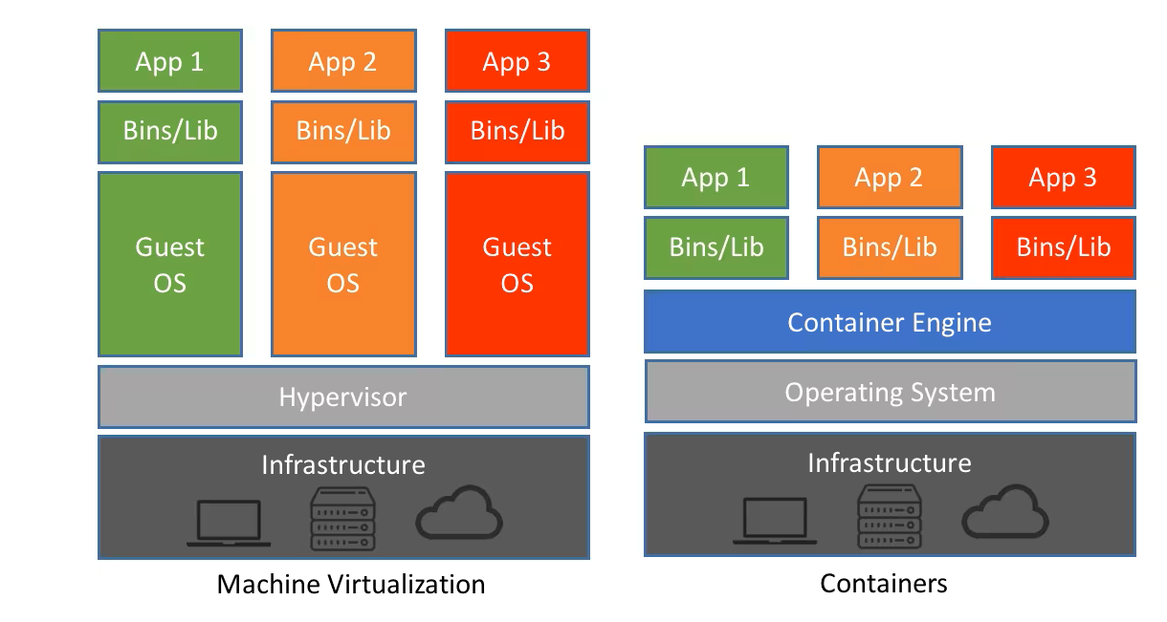

Figure 1.4.7.1: Comparison of container vs Virtual machine architecture.

Resource Efficiency

Containers are more lightweight than virtual machines (VMs) because they share the host operating system's kernel. This results in higher resource efficiency and faster container startup times compared to VMs.

Isolation

VMs provide stronger isolation by emulating entire operating systems. While VMs are suitable for scenarios requiring robust isolation, containers are preferred for their efficiency and portability.

Containerization vs. Serverless Computing

Portability and Control

Containers offer more control over the application environment and are highly portable across different platforms. Serverless computing abstracts infrastructure management but may limit control over the environment.

Scalability and Resource Management

Containers provide more flexibility in scaling and resource management, allowing precise control over resource allocation. Serverless computing automatically scales based on demand but may have limitations in resource customization.

### Containerization in Cloud-Native Development

Cloud-Native Concepts

Containerization is a fundamental technology in cloud-native development, enabling the creation of scalable, resilient, and flexible applications designed for modern cloud environments. It complements other cloud-native technologies such as service mesh and APIs.

AWS App2Container: Simplifying Legacy Application Modernization

AWS App2Container is a containerization tool provided by Amazon Web Services (AWS) that helps developers modernize legacy applications by converting Java and .NET applications.

## **Comparison between Containers and Virtual Machine**

Containerization and virtualization are fundamental technologies that enable efficient software deployment and resource utilization. Each technology offers unique benefits and use cases, making it essential for organizations to understand their differences and determine which suits their specific needs.

The purpose of this section is to provide a comprehensive comparison between containerization and virtualization. We will delve into the concepts, advantages, disadvantages, and use cases of both technologies. By the end of this report, readers will have a clearer understanding of when to choose containerization or virtualization for their IT infrastructure.

### Definition and Concept of Virtualization

Virtualization involves running multiple operating systems (OS) on a single physical server. It is achieved using a hypervisor, which allocates CPU, RAM, and storage resources to multiple virtual machines (VMs). Each VM operates as an independent environment with its OS.

### Hypervisor and Resource Allocation

A hypervisor, also known as a virtual machine monitor, plays a pivotal role in virtualization. It manages the allocation of hardware resources to VMs, ensuring isolation between them. The shared hardware resources enable cloud providers to achieve economies of scale.

### **Advantages and Disadvantages**

Virtualization offers advantages such as resource isolation, flexibility, and centralized management. However, it requires substantial RAM and CPU resources due to the need for each VM to include its OS. Moving VMs across different environments can be challenging.

### Definition and Concept of Containerization

Containerization is a form of virtualization that packages applications, along with their dependencies, into isolated containers. These containers share the host OS kernel, making them lightweight and portable. Containerization is ideal for running multiple processes within a single OS instance.

Microservices and Containerization

Containerization aligns well with microservices architecture, where applications are divided into isolated components. Each container represents a specific microservice, enhancing scalability and resilience. Updates can be applied independently to individual containers.

### Advantages and Disadvantages

Containerization offers advantages such as resource efficiency, rapid scaling, and simplified management. However, it relies on the host OS, limiting compatibility between different OS types. Security vulnerabilities in the host OS kernel pose risks to all containers on the same host.

### Key Differences Between Virtualization and Containerization

This section highlights the primary differences between virtualization and containerization:

Isolation

Virtualization isolates each VM with its complete OS, while containerization isolates containers within the host OS.

Different Operating Systems

Virtualization allows running multiple OS types on the same server, while containerization relies on the host OS.

Guest Support

Virtualization supports a range of operating systems, whereas containerization depends on the host OS.

Deployment

Virtualization uses hypervisors for deployment, while containerization utilizes Docker for individual containers or Kubernetes for orchestration.

Persistent Virtual Storage

Virtualization assigns virtual hard disks (VHDs) or shared storage, while containerization typically uses local storage with shared storage options like SMB.

Virtual Load Balancing

Virtualization uses failover clusters and load balancing, while containerization relies on orchestration to maximize resource utilization.

Virtualized Networking

Virtualization employs virtual network adaptors (VNA) with a master NIC, whereas containerization offers lightweight network virtualization.

### Choosing Between Containerization and Virtualization

Use Cases

Containerization is suitable for short-lived tasks, while virtualization is preferred for longer-term operations.

Resource Efficiency

Containers offer higher resource efficiency than VMs due to their lightweight nature.

Lifecycle Considerations

Consider the lifecycle of your applications when deciding between containerization and virtualization.

Organizational Goals and Skillsets

Assess your organization's goals and skillsets to determine which technology aligns better with your IT strategy.

Future Trends and Integration

Containerization and virtualization are converging in some areas, presenting opportunities for hybrid solutions. Future trends may see increased integration between the two technologies, providing flexibility and efficiency in IT infrastructure.

Containerization and virtualization are both valuable technologies with distinct characteristics and use cases. Organizations should carefully assess their requirements and goals to choose the technology that best aligns with their IT strategy.

Based on the analysis provided in this report, it is recommended that organizations consider a hybrid approach that leverages both containerization and virtualization where appropriate. This approach allows for flexibility, scalability, and efficient resource utilization.

## **Linux and Windows Containers**

Containerization technology has gained widespread popularity, offering benefits such as portability, security, and efficient resource utilization. However, there are significant differences between Linux containers and Windows containers that impact their usability, compatibility, and tooling.

This report aims to provide a comprehensive analysis of Linux and Windows containers, shedding light on their differences and guiding readers in choosing the appropriate containerization solution for their specific requirements. It explores compatibility, tools, and implications for container adoption.

Linux Containers vs. Windows Containers

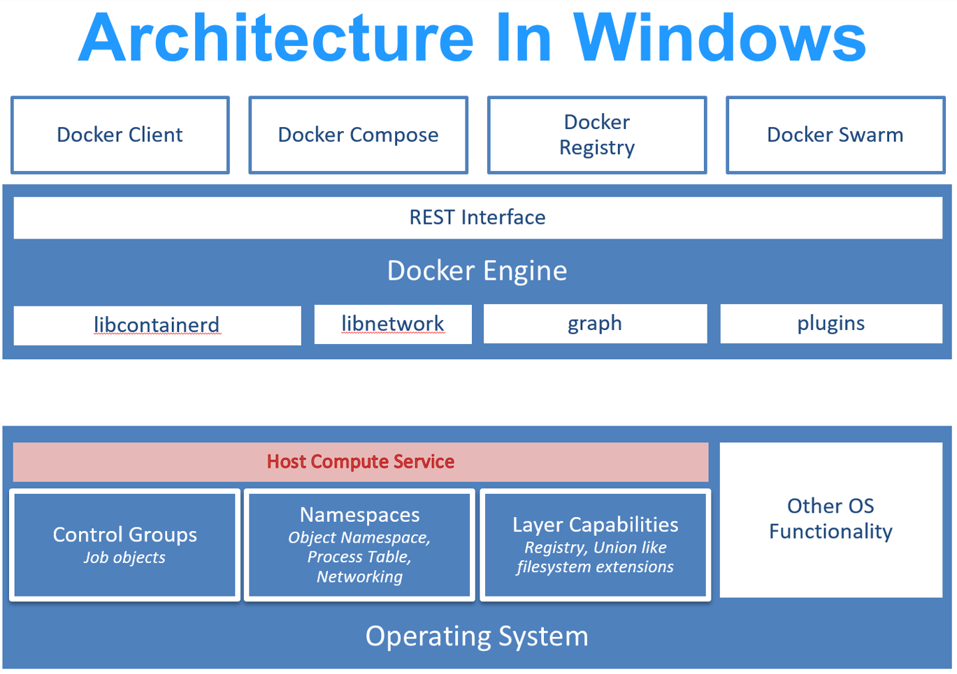

Figure 1.6.1.1: Architecture of Docker in windows server.

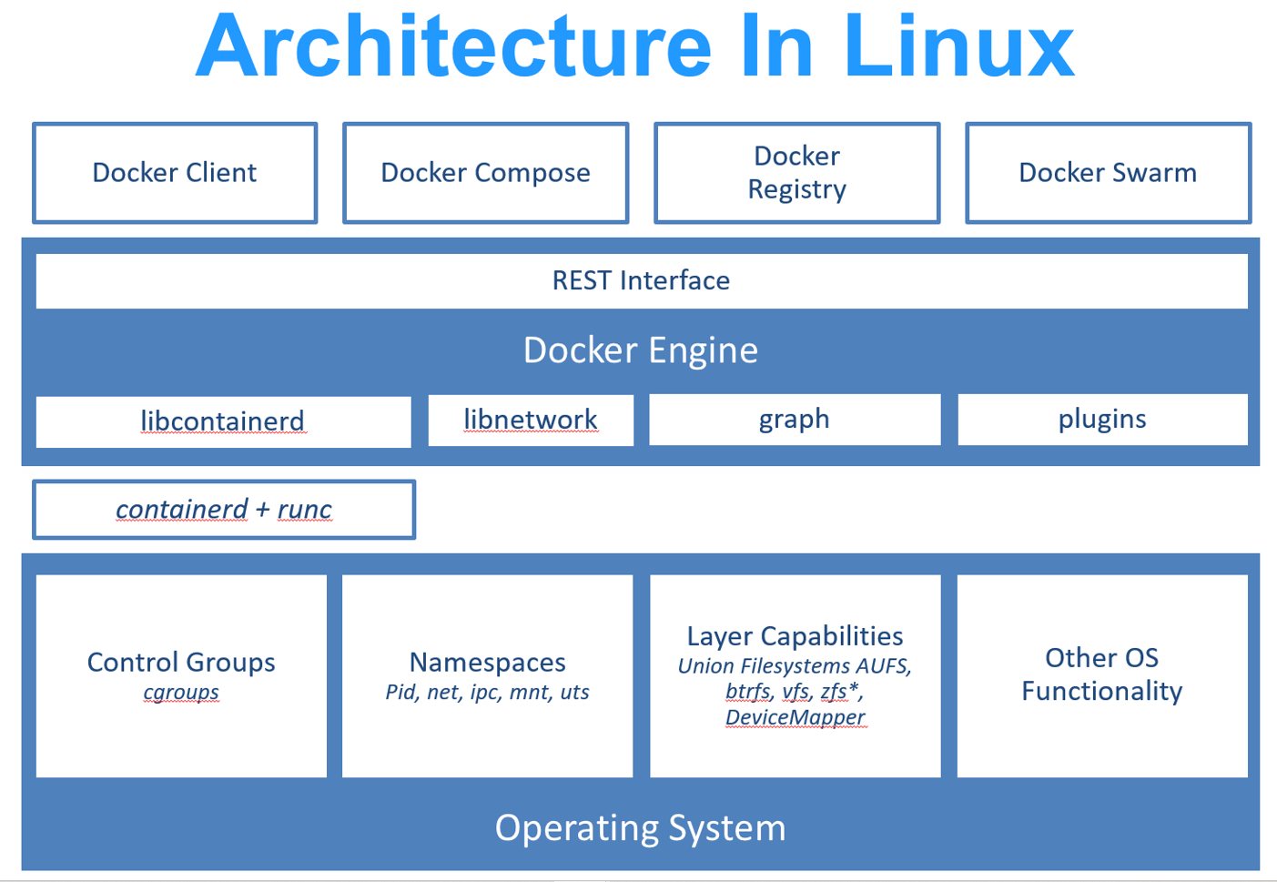

Figure 1.6.1.2: Architecture of Docker in Linux environment.

Compatibility and Supported Versions

Linux containers are known for their compatibility with various Linux distributions. Docker can run on any Linux system with a kernel version of 3.10 or later. In contrast, Windows containers have limited compatibility, primarily supporting Windows 10 desktop systems and Windows Server 2016 and 2019. This limitation restricts the deployment of containerized applications on modern Windows versions.

GUI Applications

Both Linux and Windows containers lack native support for graphical user interfaces (GUIs) within applications. While solutions like RDP or VNC can enable GUI connections, they introduce complexities and security risks. Given the prevalence of GUI-based applications in Windows environments, this limitation is more significant for Windows containers.

Hyper-V Mode

Windows containers offer two deployment modes: running containers directly on the host (Windows Server Containers) and using specialized Hyper-V instances to host containers. In contrast, Linux containers do not have an official equivalent of Hyper-V mode. Linux users can set up virtual server instances themselves but lack the built-in support seen in Windows.

Container Ecosystem

Linux containers are part of an open-source ecosystem that works across various Linux distributions without strong vendor dependencies. In contrast, Windows containers are closely aligned with Microsoft, raising concerns about long-term support and flexibility in a Windows-centric environment.

Tools for Running and Managing Containers

Mirantis Container Runtime

Mirantis Container Runtime (MCR), formerly Docker Engine - Enterprise, provides an enterprise-grade containerization solution with a focus on security. It offers easy container building and running, cryptographic module validation, and enterprise support. MCR is suitable for development and production environments, including Windows.

Docker Desktop

Docker Desktop is a developer-centric solution that enables container building and running on Windows 10 and 11. It supports both Linux and Windows containers but is primarily designed for developer machines and non-automated workflows. Docker Desktop is not available for Windows Server.

Docker CE

Docker CE, known as a distribution of Moby, is challenging to use on Windows due to limitations in installation scripts and missing components. Community-provided solutions like Stevedore exist to simplify Docker CE installation on Windows.

containerd (+ nerdctl)

Microsoft has embraced containerd as its primary runtime for Windows Server containers. containerd provides container execution services but lacks built-in tools. nerdctl, a project inspired by Docker, offers a command-line interface for containerd, although it is still evolving in terms of Windows support.

Choosing the Right Tool

Individual Development

For individual development, Docker Desktop provides a user-friendly experience for building and using containers on Windows. It supports both Linux and Windows containers, making it suitable for developers.

Running Windows Container Workloads at Scale

When running Windows container workloads at scale, Mirantis Container Runtime is a recommended choice. It offers enterprise-grade support, security, and validated cryptographic modules for production environments. Azure Kubernetes Service (AKS) is another option for fully managed Windows container clusters.

Linux and Windows containers exhibit significant differences in compatibility, GUI support, deployment modes, and vendor relationships. These differences impact the choice of containerization tools and their suitability for various use cases.

Based on the analysis presented, organizations and individuals should carefully evaluate their needs, compatibility requirements, and long-term considerations when selecting between.

# **Objective 2**

## **Docker in Containerization**

This section explores the concept of Docker, a pioneering container platform, and investigates the underlying factors contributing to its remarkable popularity within the IT industry. Docker has introduced a revolutionary approach to software execution, reshaping the landscape of software development and delivery. By dissecting Docker's fundamental principles, this report aims to elucidate its significance and the key drivers behind its widespread adoption.

In the dynamic realm of IT, Docker has emerged as a prominent entity in the past half-decade, spearheading a transformation in the realm of software development and delivery. This report seeks to provide a comprehensive comprehension of Docker while shedding light on the reasons underpinning its widespread acclaim.

Docker is an innovative technology that empowers development teams to construct, govern, and secure applications across diverse environments. To fully grasp Docker, it is imperative to first grasp the concept of containers and their operational mechanisms.

Containers represent a unique category of processes, isolated from other processes, endowed with exclusive resources that remain inaccessible to any other process. Containers remain impervious to resource access unless explicit assignments grant access, ensuring a high degree of isolation.

### The Importance of Containers

Preceding the era of containers, non-containerized processes could freely request access to any file on disk or network socket without constraints. Containers revolutionize this paradigm by confining processes within a resource "sandbox," precluding any unsanctioned access to external resources. On a single host, two containers exhibit isolation akin to separate machines.

Containerization presents several advantages:

Isolation: Containerized processes coexist without interference.

Data Security: Containers cannot breach each other's data boundaries unless deliberate configurations permit such access.

Hardware Optimization: Multiple applications can efficiently share hardware resources, mitigating the need for extensive server deployments.

### Deciphering Docker

Docker encompasses both a corporate entity and a product, with Docker Inc. responsible for developing the Docker container toolkit. While containers have existed for over a decade, their intricate nature hindered widespread adoption. Crafting containers required expertise in diverse technologies such as namespaces and cgroups, limiting accessibility to a select few.

Docker Inc. streamlined container creation by encapsulating the intricacies of underlying OS syscalls. The user-friendliness of Docker ignited a surge in popularity, culminating in the open sourcing of Docker by the company in March 2013. In a relatively brief period, Docker has wrought transformative change upon the industry, akin to the impact of Virtual Machines in the early 2000s.

### The Ascendancy of Docker

Docker's ascendancy is palpable, as evidenced by sustained growth in Google Trends data. Searches for "docker" have consistently trended upward since its introduction in 2013. Docker has emerged as the de-facto standard for containerization, eclipsing competitors like CoreOS/rkt.

### Rationales for Docker's Popularity

Docker's widespread appeal derives from the manifold advantages it bestows upon software development and deployment:

User-Friendly Interface: Docker is renowned for its accessibility, backed by abundant educational resources. Its open-source nature facilitates swift adoption across diverse operating systems.

Scalability: Containers enable the execution of numerous workloads with reduced hardware, leading to cost savings and scalability.

Streamlined Software Delivery: Containers, being portable and self-contained, eliminate inconsistencies during software distribution.

Versatility: Docker integrates seamlessly with container orchestrators like Kubernetes, proficiently managing intricate systems and extensive deployments.

Software-Defined Networking: Docker supports software-defined networking, permitting isolated virtual networks for containers, bolstering security.

Microservices Paradigm: Docker aligns harmoniously with the microservices paradigm, simplifying the deployment of intricate, distributed systems.

### Appropriateness of Docker Usage

While Docker offers substantial advantages, its adoption warrants cautious consideration:

Skillset Evaluation: Assess your team's readiness and training requirements for containerization.

Risk Assessment: Exercise prudence in regulated industries or scenarios involving mission-critical workloads.

Talent Availability: Acknowledge the scarcity of experienced Docker professionals.

Complexity Appraisal: Gauge whether your system's complexity justifies containerization.

Docker has catalyzed a revolution in software development and delivery, ushering in an era characterized by enhanced efficiency and scalability. Although not a universal panacea, Docker's merits render it an appealing option for organizations seeking to elevate their software deployment and management capabilities.

## **Docker Architecture**

This section provides a comprehensive understanding of Docker's architecture, elucidating its core components and functionalities. Docker has transformed the software development landscape by enabling the effortless creation, distribution, and execution of applications within lightweight containers. Through detailed explanations, illustrative code examples, and practical insights, this report delves into Docker's architecture, empowering readers to harness its capabilities effectively.

Docker has ushered in a paradigm shift in the way applications are developed, deployed, and managed. Its architecture offers a lightweight and efficient platform for encapsulating applications within self-contained containers. This report delves deep into the core components of Docker, elucidating their roles and providing hands-on examples to facilitate comprehension.

### Docker Architecture Overview

Docker's architecture comprises four fundamental components:

**Docker Engine**

At the core of Docker's architecture lies Docker Engine, responsible for building, running, and managing containers. Docker Engine's triumvirate consists of the Docker Daemon, REST API, and Command Line Interface (CLI), collectively driving containerization.

**Images**

Immutable templates known as Docker images serve as the foundation for creating containers. These images consist of a base image and layers containing modifications. Images play a pivotal role in container instantiation.

**Containers**

Running instances of Docker images, containers provide isolated environments for application execution. Containers are sandboxed from both each other and the host system, ensuring separation and security.

**Registries**

Docker Registries act as repositories for storing and distributing Docker images. Whether in public or private form, these registries facilitate seamless collaboration, sharing, and accessibility of images.

Exploring Docker Components in Detail

**Docker Engine**

Docker Engine, the heart of the architecture, comprises three pivotal constituents:

Docker Daemon: Serving as the background service, the Docker Daemon manages containers on the host system.

REST API: Providing a programmatic interface, the REST API enables interactions with Docker and container management.

Command Line Interface (CLI): The CLI offers a user-friendly command-based tool for Docker interaction, simplifying operations.

**Images and Containers**

Docker images are constructed from Dockerfiles, containing step-by-step instructions for layer-by-layer image creation. Containers are living instances of images, delivering isolated environments for application execution. Image layers optimize storage and facilitate efficient sharing of common components.

### Best Practices for Docker Usage

* Essential best practices for Docker utilization:
* Opt for official base images for security and reliability.
* Minimize image size by reducing layers and eliminating redundant components.
* Implement container orchestration tools like Kubernetes for intricate deployments.
* Regularly update and patch images to address security vulnerabilities.

Docker's architecture provides a potent solution for packaging and deploying applications within containers. Understanding its components empowers developers to streamline application deployment and management across diverse environments. With Docker's ability to simplify the software development lifecycle, it has become an indispensable tool for modern development practices.

## **Docker Versions**

Docker is a widely used containerization platform that simplifies application deployment. One essential aspect of Docker is version management, encompassing both the Docker CLI and Docker Engine. This report delves into the significance of Docker versioning, including the commands used to check version information.

### Docker Version Commands

Docker provides commands for checking version information:

**docker version**

The docker version command reveals the current version details for various Docker components. This includes both the Docker CLI and the Docker Engine. It can be customized using the --format option.

By default, the command splits version information into two sections: "Client" and "Server." The "Client" section pertains to the Docker CLI and client components, while the "Server" section focuses on the Docker Engine and related components, such as "Containerd" and "Runc" OCI Runtimes.

Example of default output:

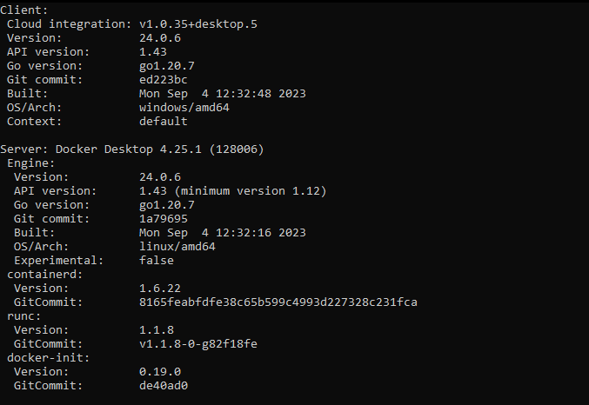

Figure 2.3.1: docker version output of docker desktop containing client and server version and other information.

**docker --version**

The docker --version command, on the other hand, exclusively provides the version number of the Docker CLI you are currently using.

### Client and Server Versions

Docker employs a client/server architecture, enabling the Docker CLI to control a remote Docker Engine. The API version used by the client is determined through version negotiation with the Docker Engine. This negotiation ensures compatibility between the Docker CLI and Docker Engine.

Example of specifying a context:

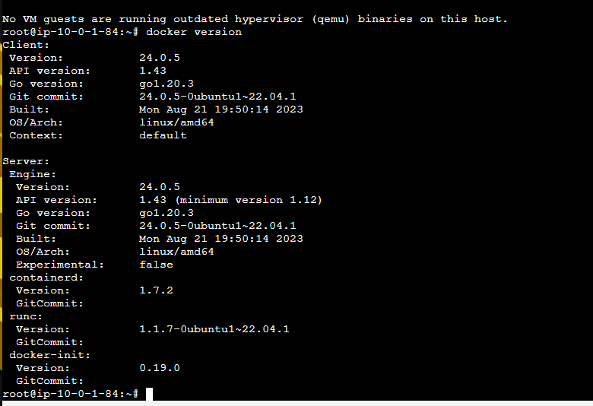

Figure 2.3.2: docker version output of docker installed in linux providing server and client version information.

### API Version and Version Negotiation

The API version used by the Docker CLI is determined by the Docker Engine it connects to. During connection, both components negotiate and select the highest supported API version. Overriding the API version can be done using the DOCKER_API_VERSION environment variable.

Understanding Docker versioning is crucial for ensuring compatibility and managing your Docker environment effectively. By using the docker version and docker --version commands, you can easily check the version information of your Docker components.

## **Container Ecosystem**

Cloud Containers have emerged as a transformative technology in cloud computing, simplifying This report delves into the Docker ecosystem, providing a comprehensive understanding of its key components, functionalities, and significance in modern software development. Docker, considered a game-changer in DevOps, has gained widespread adoption among both small and large enterprises. The report explores Docker's core concepts, including images, containers, Dockerfiles, and its pivotal role in containerization. It also discusses essential Docker tools, such as the Docker client, Docker server, Docker Hub, and Docker Engine, highlighting their respective roles in managing containers. Furthermore, the report touches upon Docker's application in service discovery and networking. Finally, it outlines the benefits of Docker, emphasizing its cost-effectiveness, portability, and support for microservices architecture.

Docker has revolutionized the world of software development with its containerization technology. In recent years, Docker has emerged as the de-facto standard for managing containerized applications, earning the favor of numerous industry giants like Airbnb, Google, IBM, Microsoft, Amazon, and Nokia. This report aims to provide an in-depth understanding of the Docker ecosystem, shedding light on its core components, functionalities, and the broader impact it has on the world of software development.

### Docker and Containerization

Docker is a relatively new technology, but its rapid adoption in the DevOps landscape is undeniable. It serves as an open platform for developers and system administrators, allowing them to deploy, manage, and run applications within containers. In this context, a container can be likened to a separate Linux system, encapsulating a complete operating system within a single machine.

The key benefit of Docker lies in its containerization platform, enabling the rapid creation, testing, and deployment of portable, self-sufficient containers. These containers are designed to run consistently across various environments, offering unprecedented flexibility in software deployment.

### Images and Containers

To understand Docker fully, one must grasp the concepts of images and containers. An image serves as a read-only template for creating containers. It includes a set of instructions that guide the execution of a container on the host operating system. Images are constructed using the "build command," allowing developers to create consistent environments for their applications.

Containers, on the other hand, are runtime instances of images. They run applications and software in an isolated environment, bundling necessary software, libraries, and configuration files. Containers communicate via well-defined channels, ensuring isolation while facilitating seamless interaction.

### Dockerfile

The Docker ecosystem heavily relies on Dockerfiles to create images. A Dockerfile is essentially a script that outlines the steps required to build an image successfully. It contains instructions for tasks such as program installation or file downloads from external sources. Dockerfiles are processed line by line, allowing for a structured approach to image creation.

An essential feature of Docker images is their layered file system. Unlike traditional methods that rewrite entire components, Docker's layered approach only records changes, preserving underlying layers and significantly speeding up the process. In essence, Docker images represent comprehensive templates for running applications, encompassing code, runtimes, dependencies, and essential file system objects.

### Docker Tools and Components

The Docker ecosystem encompasses a multitude of tools and components, making it a vital asset for standardizing software development practices. Several key components contribute to Docker's functionality:

Docker Client: The Docker client, implemented as a "Go" program, serves as a user interface to interact with the Docker daemon (the Docker engine). This client is responsible for sending commands to the daemon, which handles container building, running, and distribution.

Docker Server: The Docker server, also known as a host, employs the Docker API to manage containers. This is where containers are deployed, abstracting the complexities of running applications. Multiple containers can coexist on a single host, promoting efficiency and collaboration.

Docker Hub: Docker Hub is a cloud-based registry service that facilitates code repository linking, image building, testing, and storage. It streamlines container image discovery, distribution, change management, collaboration, and workflow automation throughout the development pipeline.

Docker Engine: Docker Engine is the core application responsible for managing the container lifecycle. It handles image creation, storage, container execution, network attachments, and more. Docker Engine can be deployed either as a container or installed directly on the host machine, making it a versatile runtime and packaging tool.

### Service Discovery and Networking

Service discovery plays a pivotal role in microservices architecture, enabling load balancing and failover. In Docker's ecosystem, service discovery tools automatically detect network nodes and configure routing between them. Prominent service discovery tools include Docker Swarm, Kubernetes, and Mesos. These tools continuously update their data based on network changes and automatically adjust load balancers, ensuring seamless service discovery and connectivity.

### Docker Networking

Docker networking relies on libnetwork, providing a native Go implementation for networking tasks. Libnetwork follows a client/server architecture, with the daemon acting as the server and client libraries offering the API for network management. This framework simplifies network configuration on Docker hosts and supports various network tools, including docker0 and Linux Bridge Utilities (Brctl).

### Scheduling, Cluster Management, and Orchestration

Scheduling is crucial for resource allocation in container environments. Docker offers basic scheduling algorithms, but more advanced algorithms consider network dependencies when determining container placement. Cluster management ensures efficient communication between nodes, enabling dynamic system scaling in response to demand fluctuations.

Container orchestration automates container provisioning, configuration, deployment, and management within container clusters. It monitors container scheduling, clustering, high availability, and scaling, ensuring failover mechanisms are in place.

In conclusion, the Docker ecosystem represents a significant paradigm shift in software development and deployment. It offers a standardized approach to containerization, enabling developers to build, test, and deploy applications seamlessly. Docker's broad range of tools and components simplifies the software development lifecycle, making it a transformative technology for modern businesses. As Docker continues to evolve and gain widespread adoption, it is poised to shape the future of software development and deployment.

# **Objective 3**

## **Docker Installation**

### Docker Installation in Windows

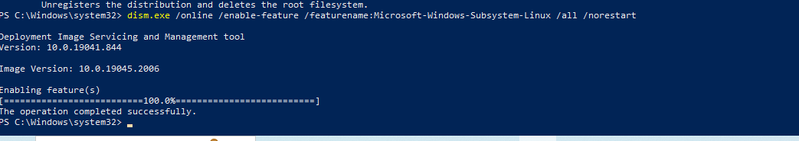

Figure 3.2.1: Prerequisite to install the docker destop is to enable windows subsystem linux using the above command.

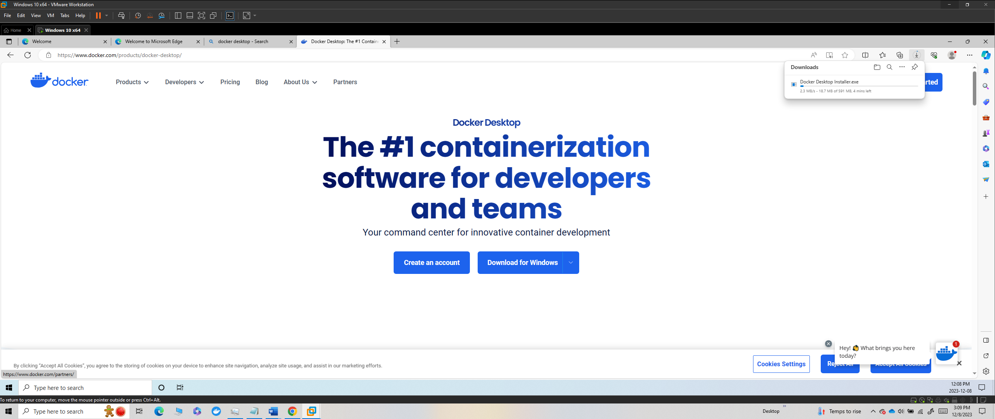

Figure 3.2.2: Download docker in windows 10.

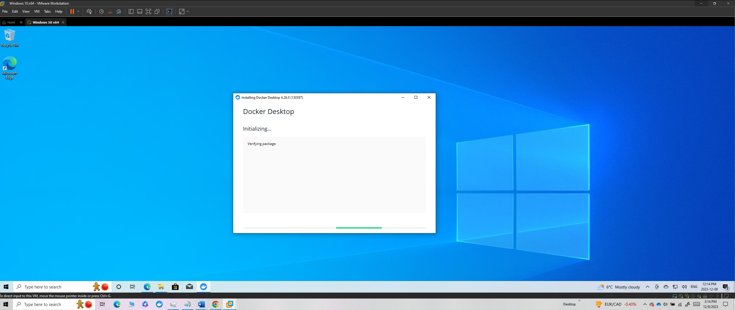

Figure 3.2.3: Installation of docker in windows 10.

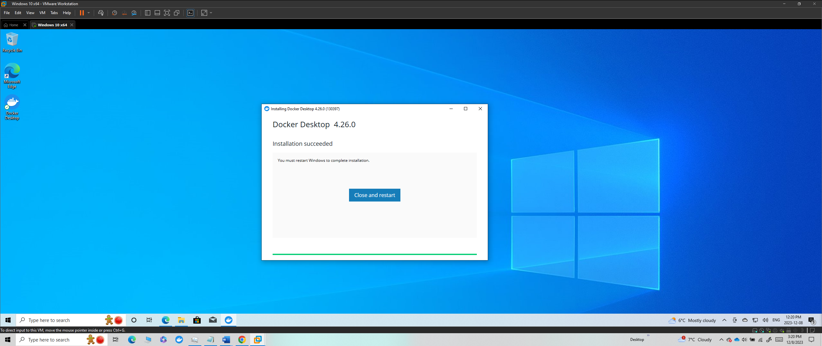Figure 3.2.4: Restart the docker desktop.

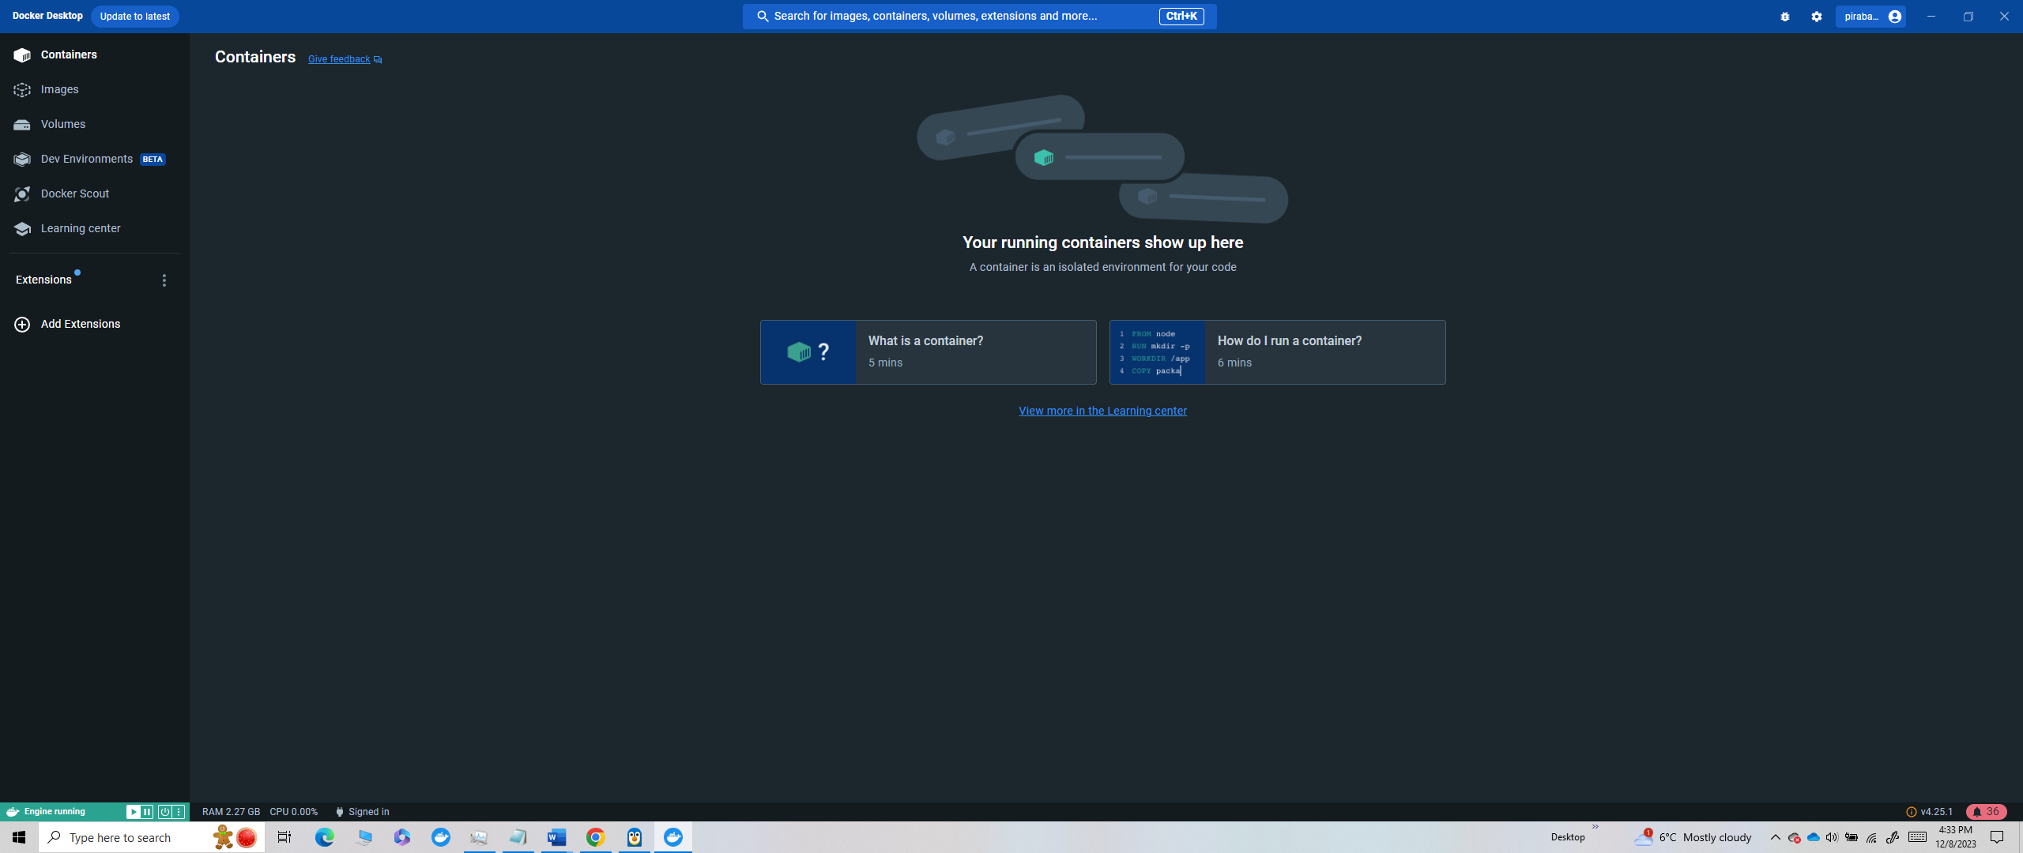

Figure 3.2.5: Installed docker desktop in windows 10.

### Docker Installation in Linux (ubuntu)

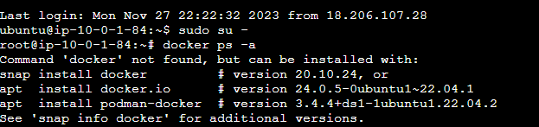Figure 3.3.1: install dicker.io in Linux server.

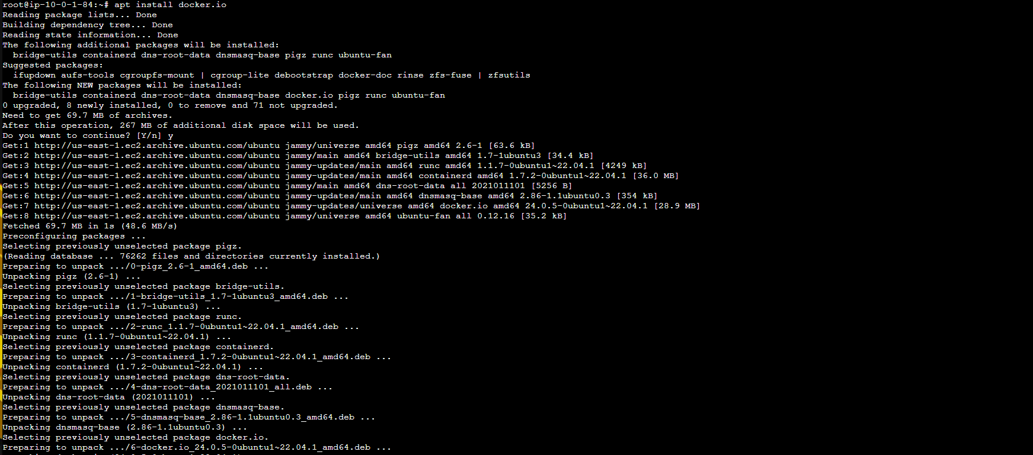Figure 3.3.2: successfully installed docker in Linux server.

Figure 3.3.3: verification of docker installation in Linux.

## **Explore Docker CLI**

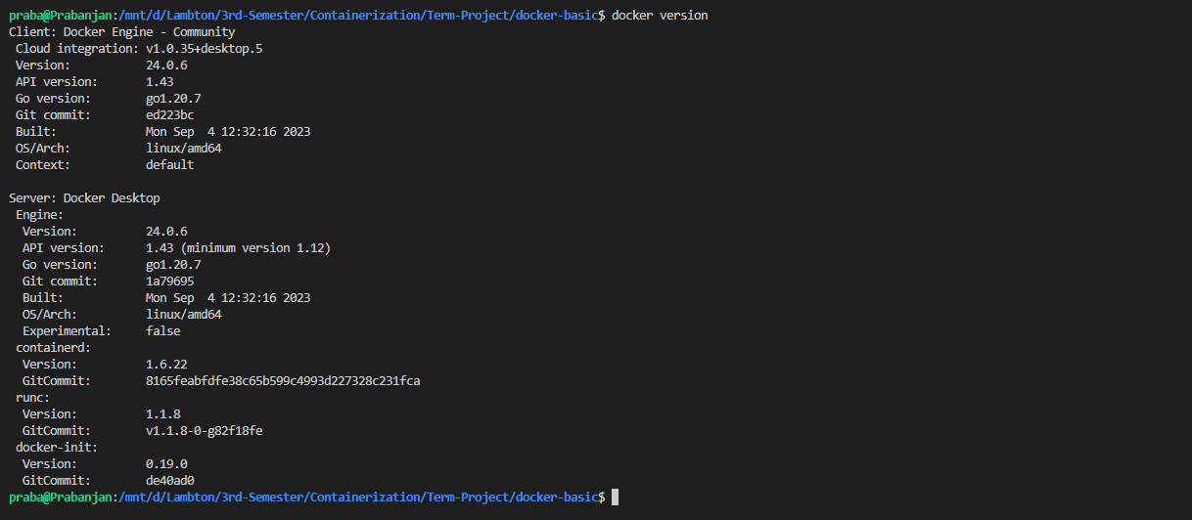

Figure 3.4.1: Docker version command.

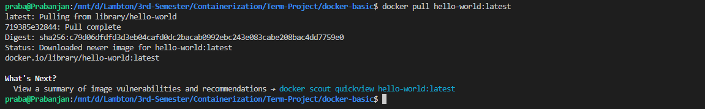

Figure 3.4.2: Pull docker image (hello-world).



Figure 3.4.3: verify the docker images pulled.

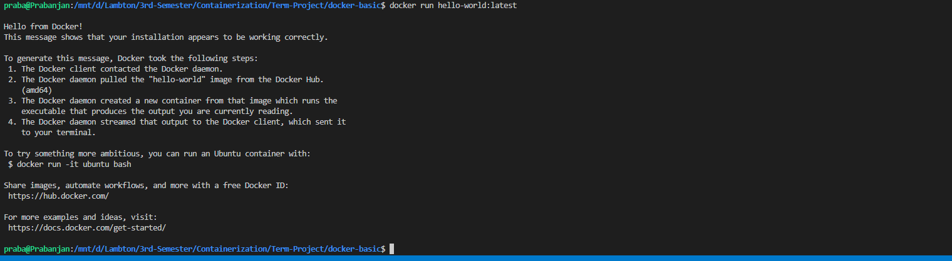

Figure 3.4.4: Docker run command to run the docker container.

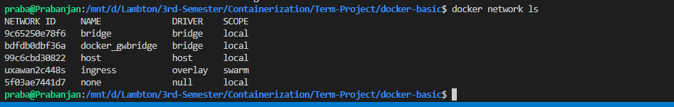

Figure 3.4.5: list the network in docker



Figure 3.4.6: list the volume in docker

## **Explore Docker Desktop**

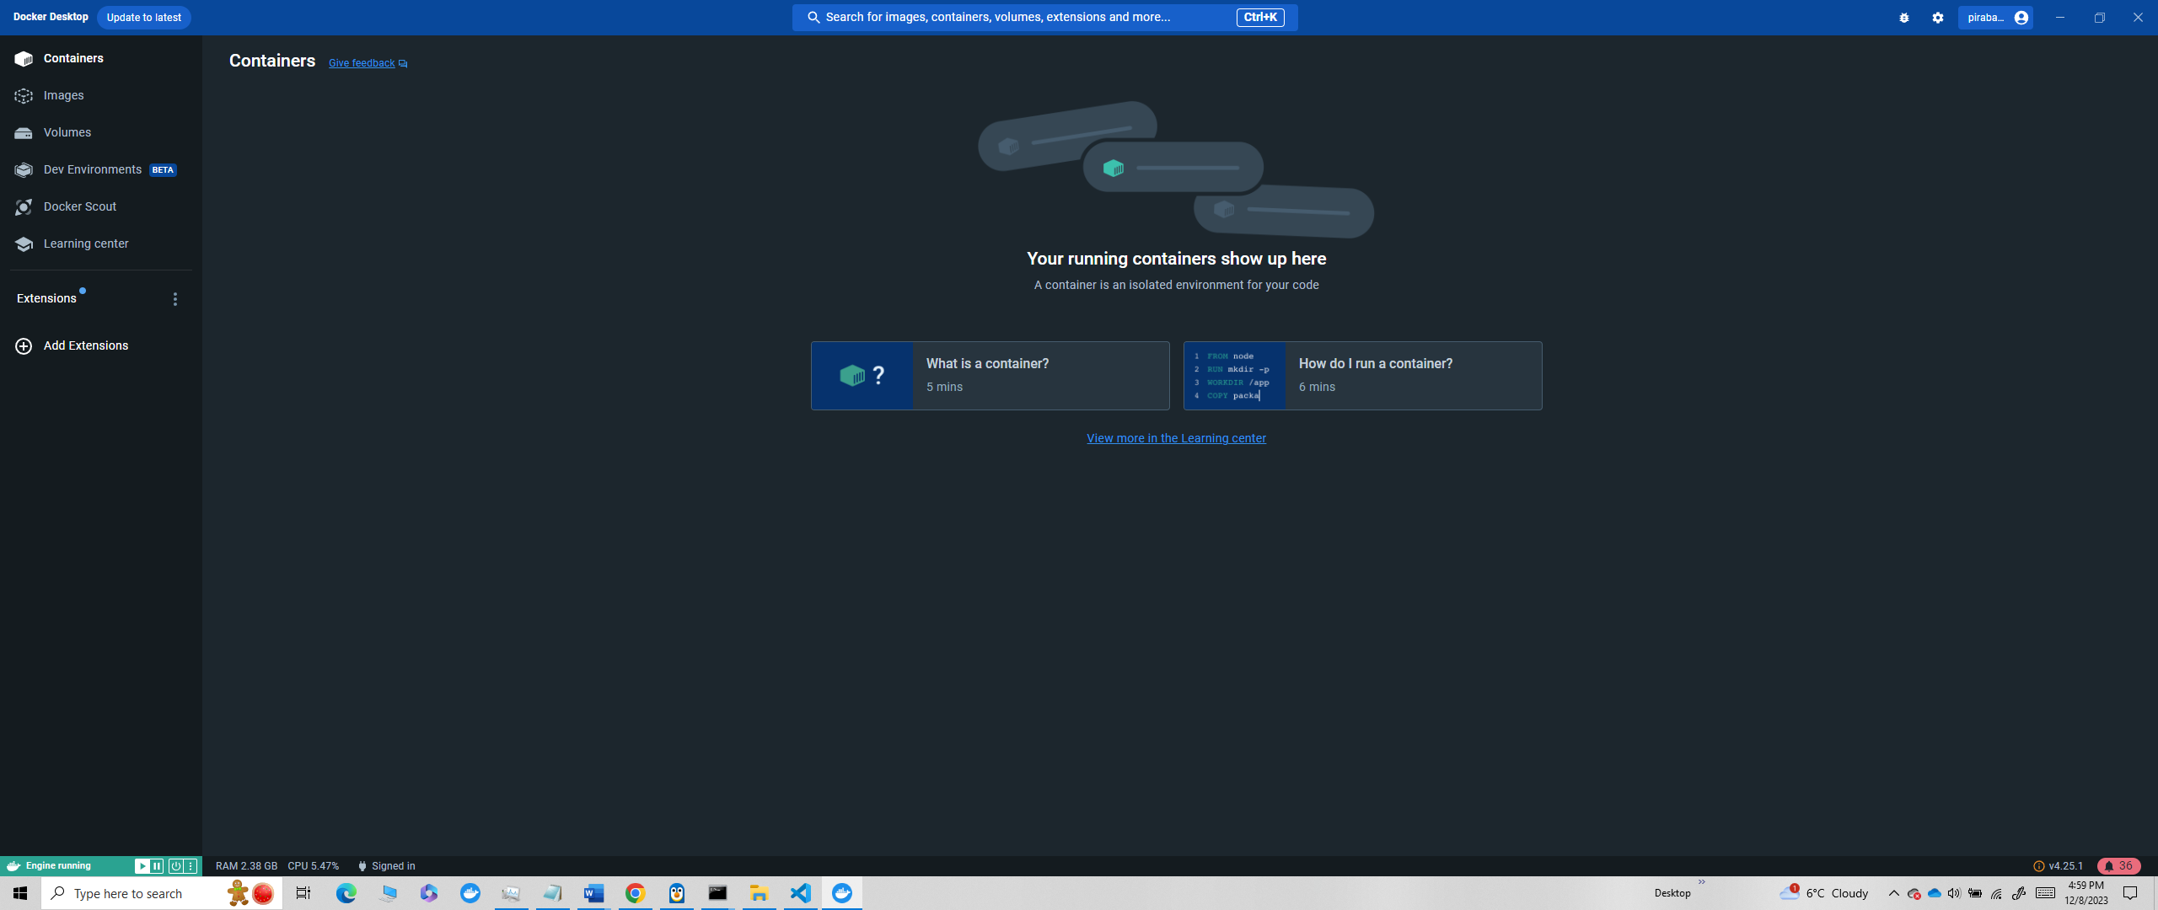

Figure 3.5.1: Docker desktop installed in windows machine.

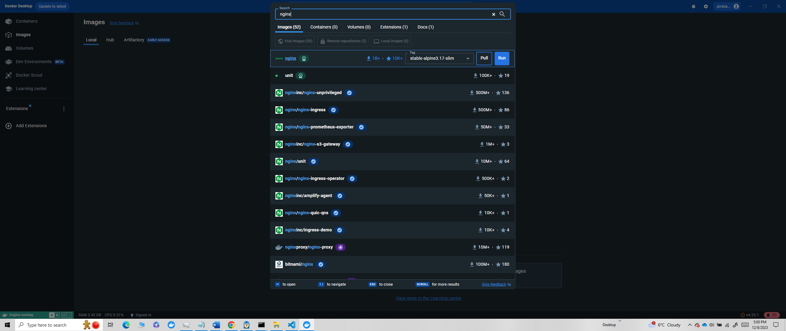

Figure 3.5.2: Select images and search for the image name to pull or run.

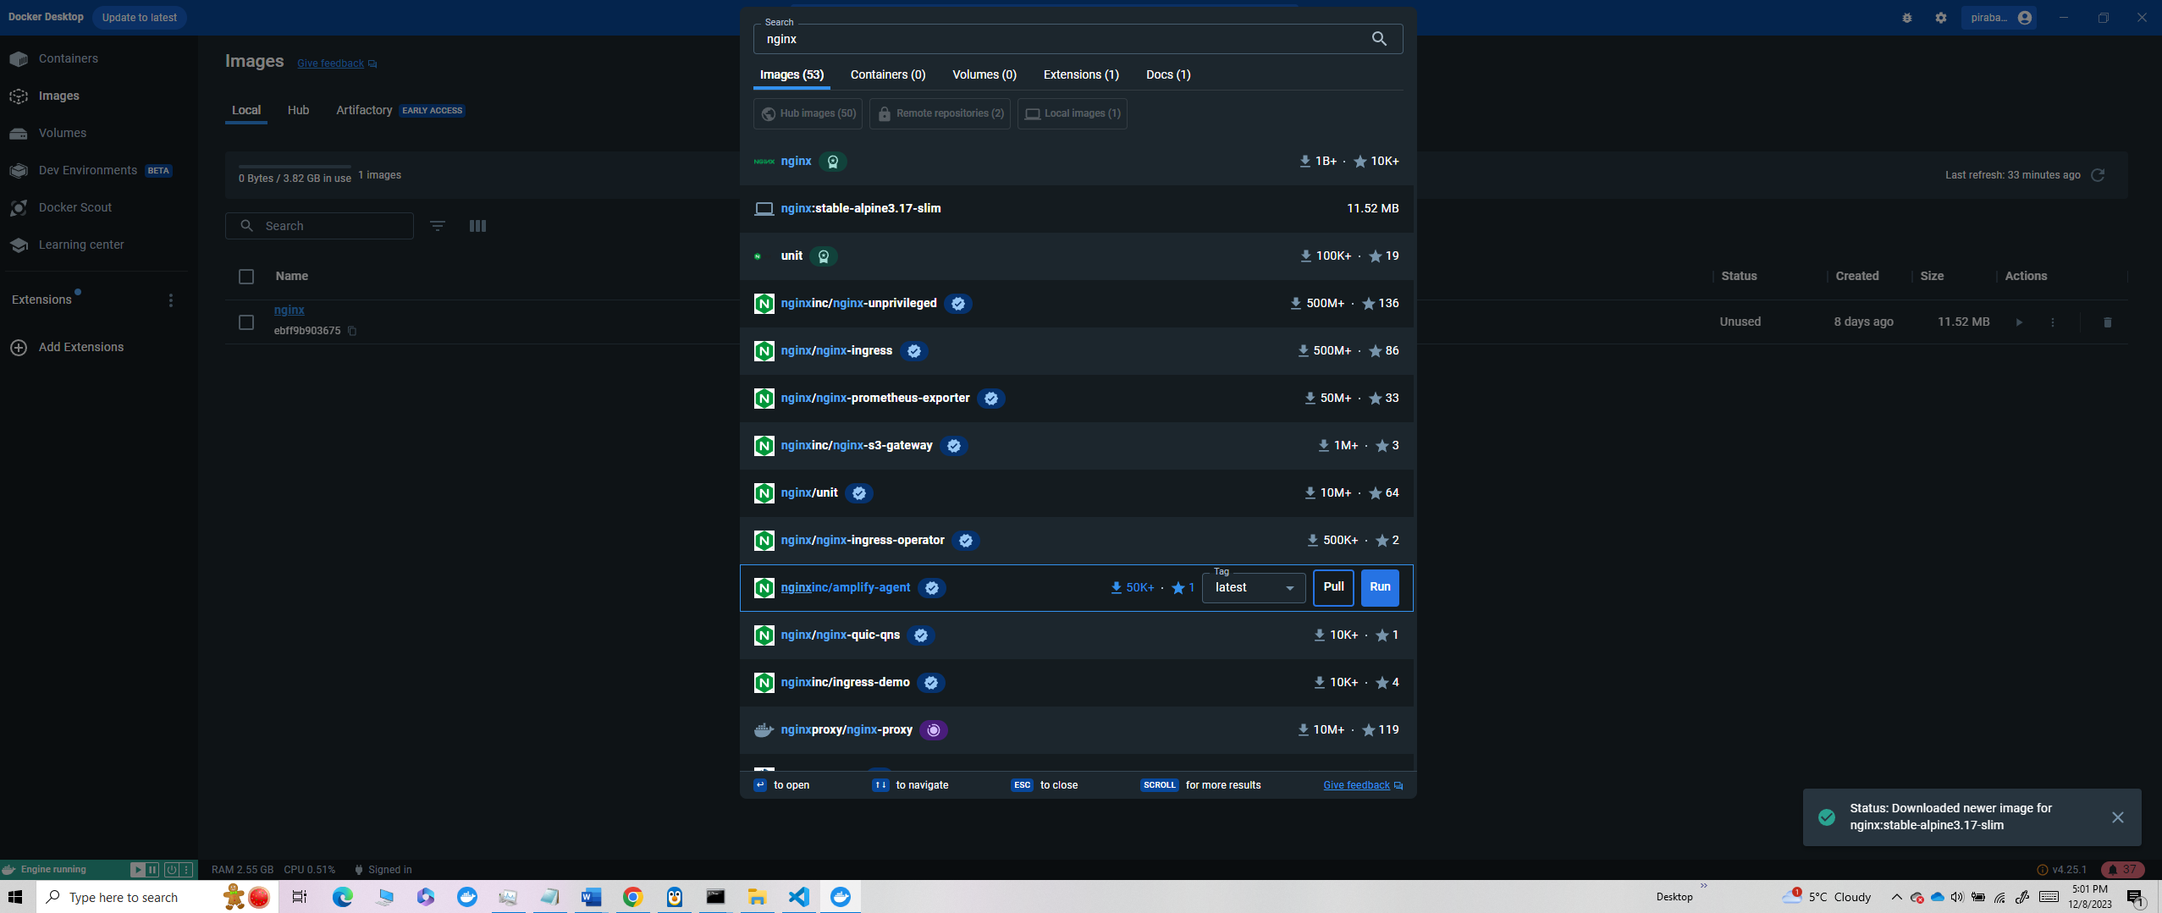

Figure 3.5.3: Pulled the docker image using docker desktop.

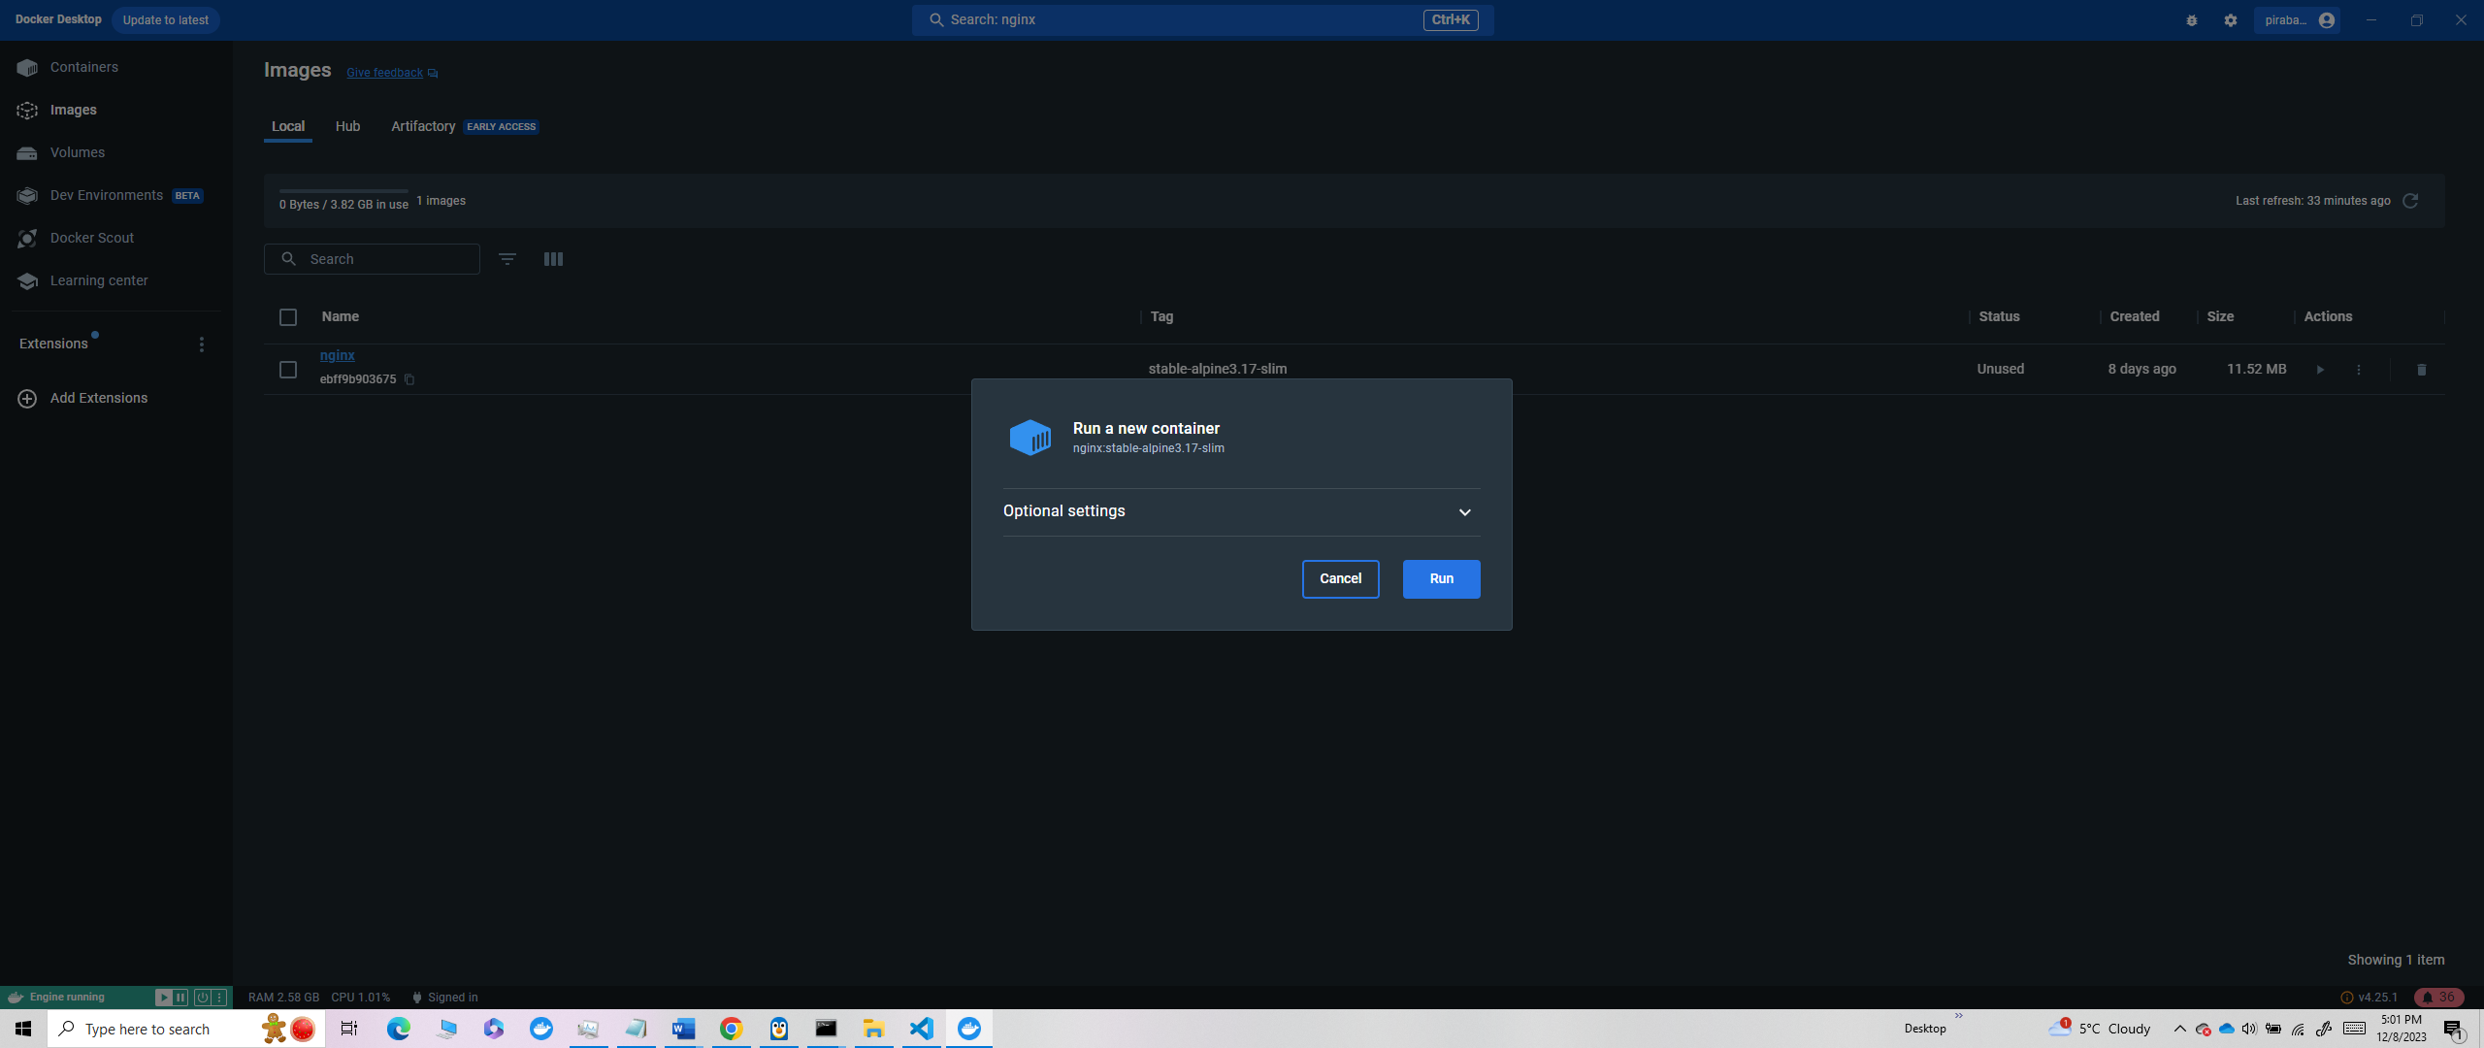

Figure 3.5.4: Clicked on run button in the image which needs to be ran.

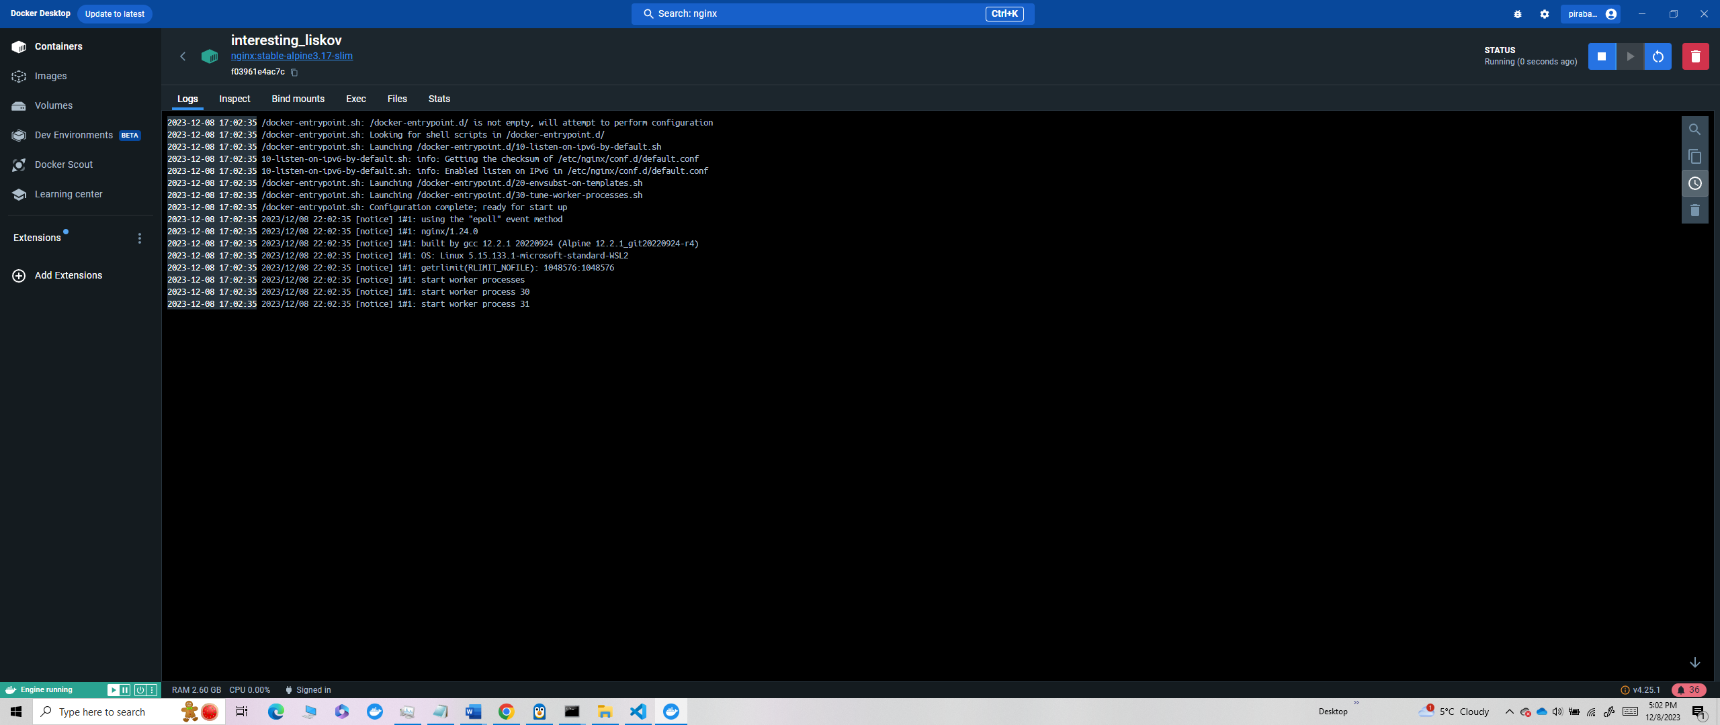

Figure 3.5.5: Docker logs for the nginx container.

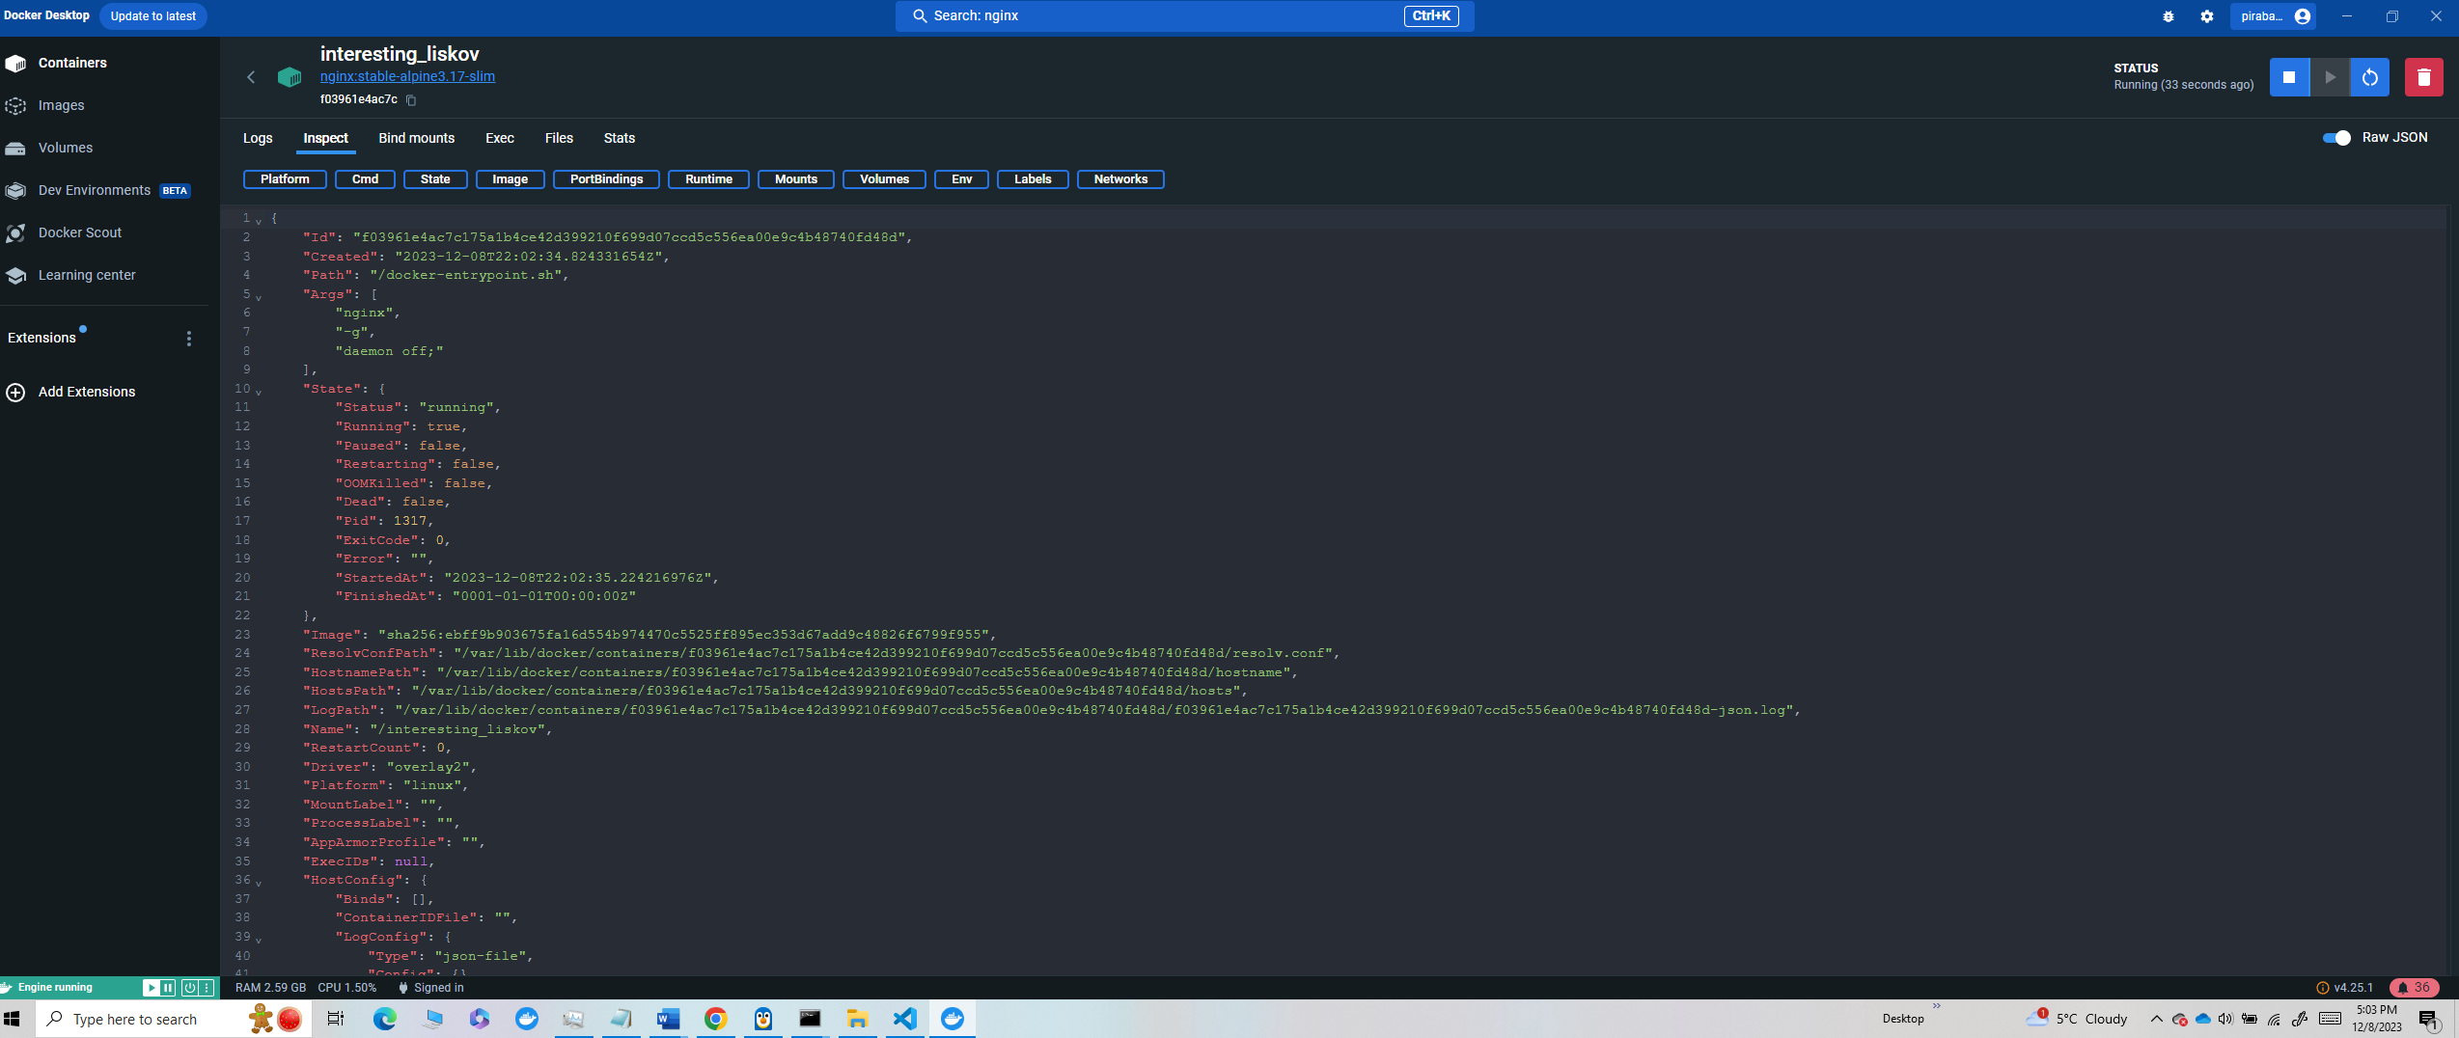

Figure 3.5.6: Inspect the docker using docker desktop, which has option to inspect state, cmd, image, port bindings, runtime, mounts and many more as shown in the figure.

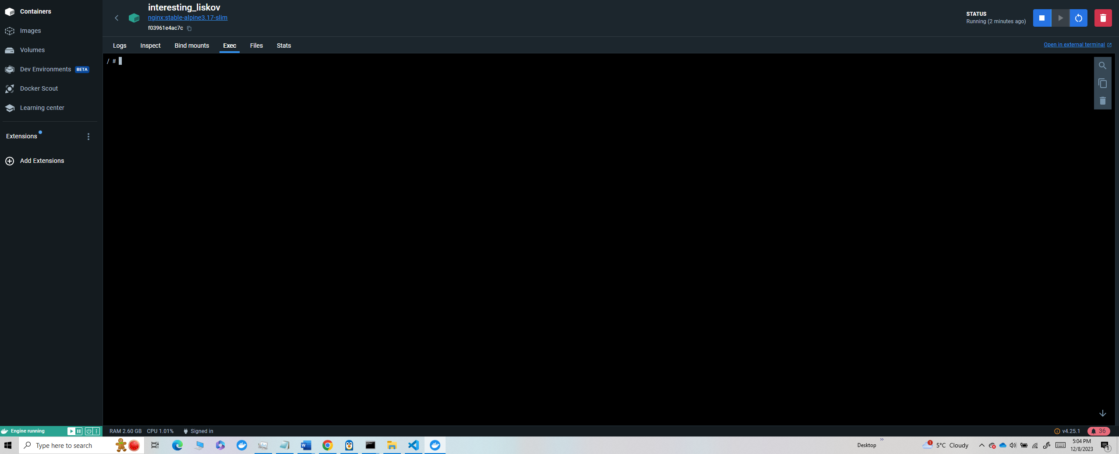

Figure 3.5.7: execute commands from running container.

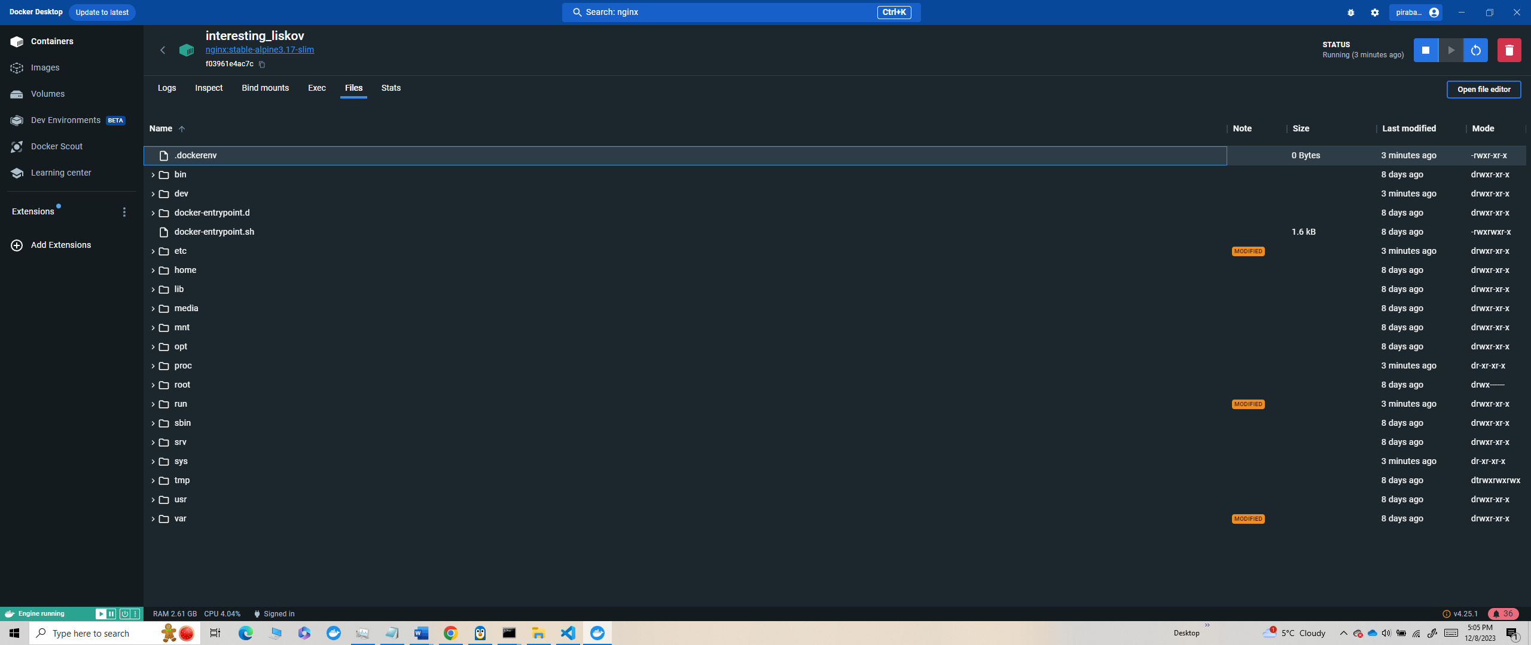

Figure 3.5.8: files inside the nginx running container viewed via docker desktop.

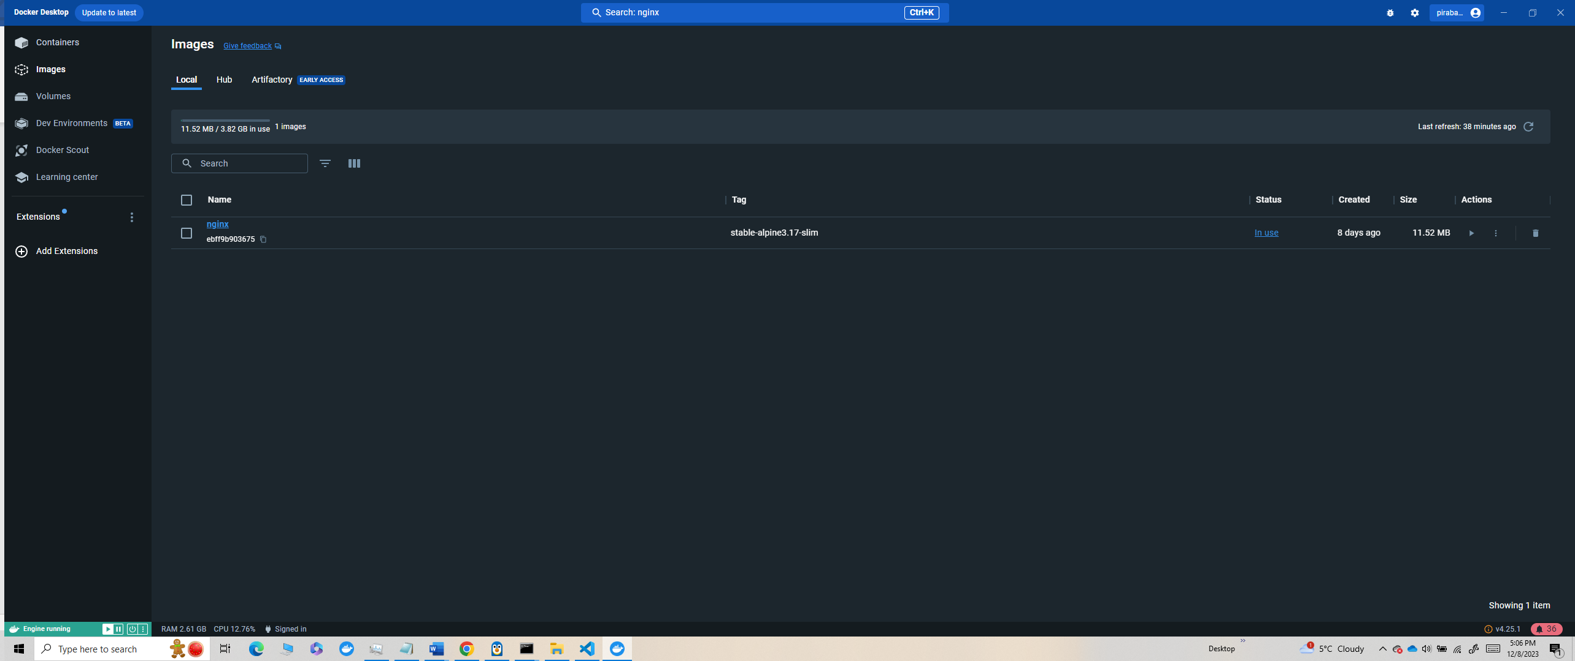

Figure 3.5.9: View the list of containers running in the host machine using docker desktop.

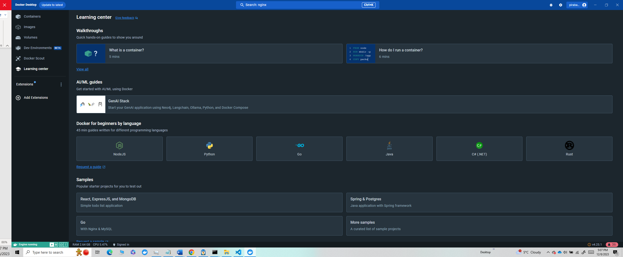

Figure 3.5.10: Has an option to learn more about docker in docker desktop providing graphical help to users new to docker.

## **Sample Docker Container**

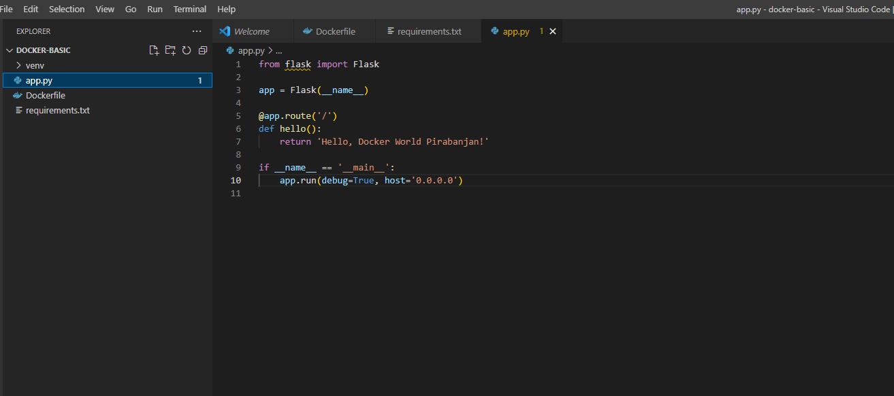

Figure 3.6.1: Create a app.py file to run simple python flask application prompt to run hello world pirabanjan.

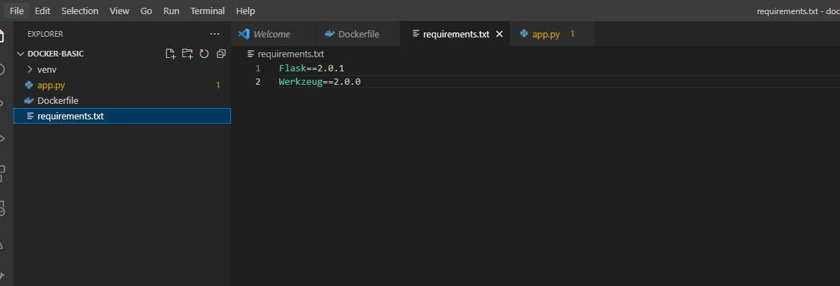

Figure 3.6.2: Create a simple requirement.txt file which helps to download the dependencies to the server/container.

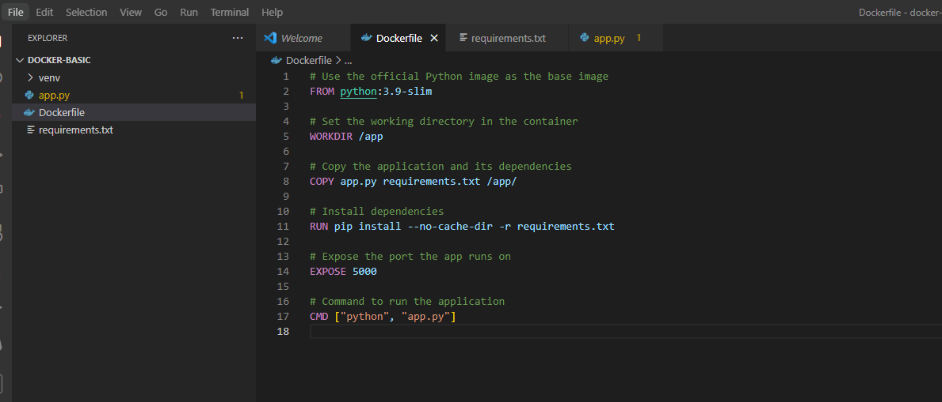

Figure 3.6.3: Dockerfile to run the application in python 3.9, create the working directory copy the app.py and requirements.txt files to the working directory, run the application inside the container exposing the port 5000.

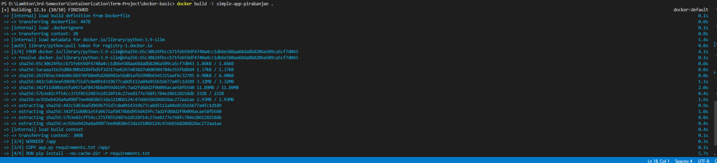

Figure 3.6.4: docker build command to build the application image.

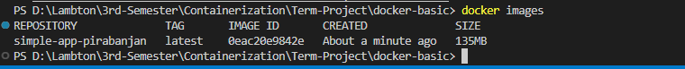

Figure 3.6.5: Verification of image created.

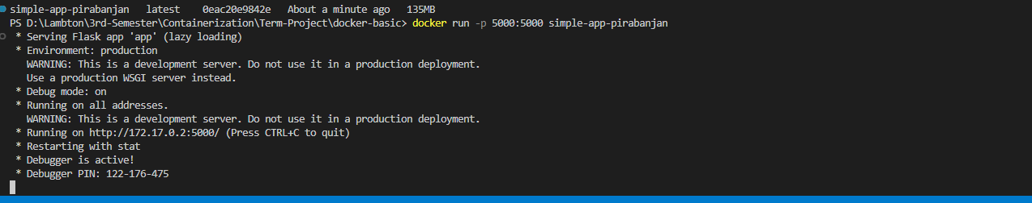

Figure 3.6.6: Run the docker container (to run the container in detach mode include -d)

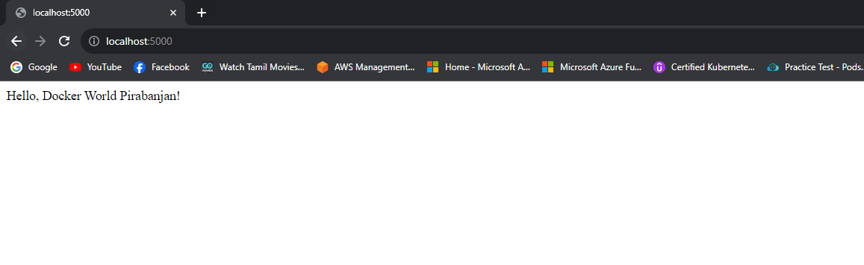

Figure 3.6.7: Application can be accessed via port 5000.

## **Explore Docker Hub**

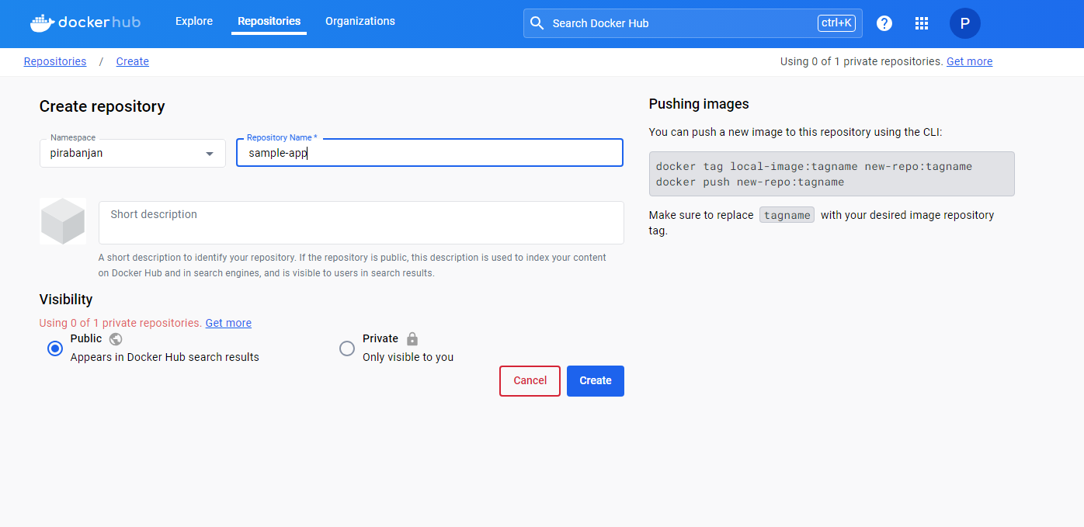

Figure 3.7.1: Login to the docker hub and create repository by providing the name for the repo.

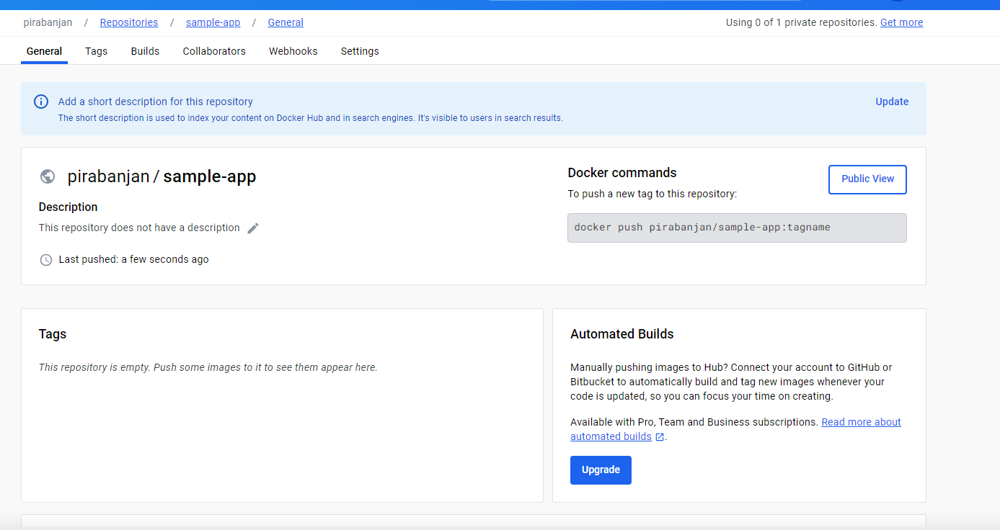

Figure 3.7.2: Created the repository successfully.

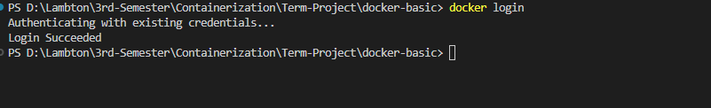

Figure 3.7.3: login to the docker hub from the local machine to push the image to docker hub.



Figure 3.7.4: Tag the docker container to push the image to docker hub.

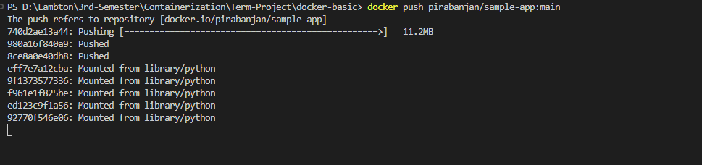

Figure 3.7.5: push the docker image from local machine to docker hub using push command.

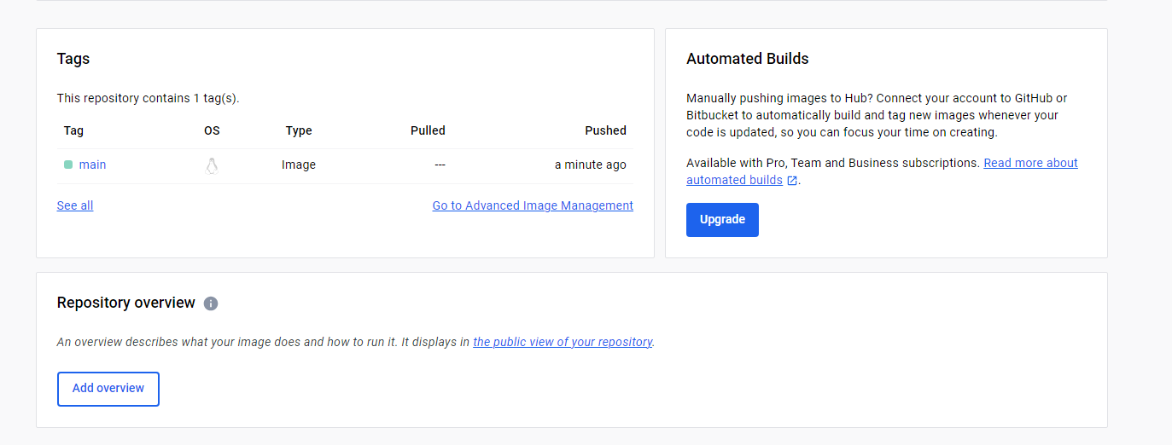

Figure 3.7.6: Docker push to the docker hub is successful.

# **Objective 4**

## **Containerization in DevOps**

The world of software development is undergoing a paradigm shift with the integration of DevOps and containerization. DevOps practices have revolutionized the software development lifecycle (SDLC) by combining automation and collaborative culture, resulting in more predictable outcomes and reduced code-related issues in production. Containerization, on the other hand, ensures consistent software environments across different stages of development, testing, and production. In this comprehensive report, we explore the concepts of containerization, its role in DevOps, common containerization tools, and how GitHub incorporates containerization into its DevOps practices.

### The Role of Containerization in DevOps

DevOps is an organizational transformation that promotes collaboration and automation to streamline software development. While not a strict requirement, containerization complements DevOps practices by enhancing reliability, speeding up delivery, and improving collaboration.

### Key Benefits of Containerization in DevOps

Greater Reliability: Containers ensure tests and security checks run consistently, aligning with the DevOps principle of making quality everyone's responsibility.

Faster Delivery: Containers simplify code integration and testing, making changes easier to manage and reducing unintended consequences.

Improved Collaboration: Container shareability facilitates collaboration by providing a consistent application environment across different hardware setups.

### How Containers Work in CI/CD

Containers play a crucial role in CI/CD (Continuous Integration/Continuous Deployment) pipelines by enhancing both speed and thoroughness. They streamline integration, testing, release, and deployment phases.

### CI/CD Stages and Containerization

Integration: Containers simplify code integration by providing a standardized development environment with required dependencies.

Test: Containers allow for rapid provisioning of test environments, reducing manual configuration and speeding up testing.

Release and Deploy: Container images, once built, are stored in registries, and can be easily deployed using orchestration tools like Kubernetes.

### Microservices and Containerization

Microservices architectures, characterized by small, specialized application units, align seamlessly with containerization and DevOps. Containers offer a one-to-one relationship with microservices, enabling easy scaling and rapid deployment.

### Common Containerization Tools

Containerization tools fall into two categories: container platforms and container orchestration tools.

### Container Platforms

Docker: A comprehensive platform for building, running, and distributing containers.

Podman: An alternative to Docker for running containers with a different approach.

Kraken: An open-source container registry for distributing containers.

### Container Orchestration

Kubernetes: The industry standard for container orchestration, ideal for managing large-scale container deployments.

Openshift Container Platform: Red Hat's open-source orchestration platform.

Azure Kubernetes Service: A SaaS offering for Kubernetes orchestration in Azure.

DevOps and containerization are driving transformative changes in software development. Containerization's benefits, including portability, scalability, and integration into DevOps, make it a valuable addition to modern development practices. Containers enhance the reliability, speed, and collaboration aspects of DevOps workflows. In a world where software is a cornerstone of innovation, embracing DevOps and containerization is not just an option; it's a necessity for staying competitive and delivering high-quality software. As organizations continue to adopt these practices, they pave the way for a future of efficient, agile, and reliable software development.

# **Objective 5**

## **Containers**

Containers and microservices have revolutionized the way modern applications are developed, deployed, and managed. This section delves into the relationship between containers and microservices, the container lifecycle, container images, their relationship, comparisons with VM images, image lifecycle, and the role of container repositories. Additionally, it highlights popular examples of container repositories.

Containers are isolated, lightweight environments that package applications and their dependencies, making them portable across various platforms. They play a vital role in microservices architecture, where applications are broken down into smaller, independent services that communicate via APIs. Containers enable the efficient deployment and scaling of microservices.

### Container lifecycle

The container lifecycle comprises several stages:

* Creation: Containers are created from container images, which serve as templates containing the application and its dependencies.
* Running: Containers execute the application or service they encapsulate, actively serving requests.
* Paused: Containers can be paused to temporarily freeze their state, enabling later resumption.
* Stopped: Containers are stopped when they are no longer needed, preserving their state but not using resources.
* Deletion: Containers are deleted when they are no longer required, freeing up resources.

## **Images**

### Container images

Container images are the building blocks of containers. They include the application code, runtime, libraries, and configurations needed to run the application. Images are immutable, meaning that once created, they cannot be changed; any modifications result in the creation of a new image.

### Containers and images

Containers are instances of container images. When a container is created, it uses the image as its foundation. Containers are isolated from each other and from the host system, ensuring that changes made to one container do not affect others. This separation is crucial for achieving consistency and isolation in microservices.

### Container images and VM images

* Container images differ from virtual machine (VM) images in several ways:
* Size: Container images are smaller, containing only the application and its dependencies, whereas VM images include an entire operating system.
* Resource Efficiency: Containers share the host OS kernel, making them more resource efficient than VMs.
* Boot Time: Containers start almost instantly, while VMs may take several minutes to boot.
* Isolation: VMs provide stronger isolation, but containers offer good isolation for most use cases.

### Image lifecycle

Container images also have a lifecycle:

* Creation: Images are created from a base image, often using a Dockerfile that specifies the application and its dependencies.
* Pushing: Custom images can be pushed to a container registry, making them available for distribution to other environments.
* Pulling: Images are pulled from container registries to local environments using the docker pull command, ensuring that the required image is available locally.
* Administration: Image administration involves tasks such as inspecting image metadata, cleaning up unused images, and removing images using the docker image command.

## **Container Repository**

A container repository is a central storage location for container images. It allows users to store, manage, and distribute container images easily. Container repositories are essential for collaboration, version control, and maintaining image integrity.

### How Container Repositories Work

Container repositories work by providing a platform for users to:

Upload Images: Users can upload their custom container images to the repository.

Download Images: Other users can pull images from the repository to their local environments.

Version Control: Repositories often support versioning, enabling users to specify which image version they want to use.

Access Control: Access to images can be controlled, allowing for secure image distribution.

### Popular Examples of Container Repositories

Docker Hub: Docker Hub is one of the most popular container repositories, hosting millions of container images. It includes both official and community-contributed images.

Amazon Elastic Container Registry (ECR): ECR is a managed container repository service provided by Amazon Web Services (AWS).

Google Container Registry (GCR): GCR is a container repository hosted by Google Cloud Platform (GCP).

Azure Container Registry (ACR): ACR is Microsoft's container registry service integrated with Azure.

## **Micro services**

### Containers and microservices

Containers and microservices have emerged as pivotal components in modern software development, offering innovative ways to design, deploy, and manage applications. This report provides an overview and comparative analysis of containers and microservices, highlighting their characteristics, benefits, challenges, and common technologies. It is important to note that these technologies are not mutually exclusive and can complement each other in various scenarios.

**Containers**

Containers can be defined as isolated processes bundled with all the necessary resources, including code, dependencies, and runtime environments, required to execute a specific task. Much like a car designed with only the essential components for transportation, containers offer simplicity and efficiency. They are highly portable and platform-agnostic, making them ideal for achieving consistency across different stacks and platforms (Nordic APIs).

**Microservices**

Microservices, on the other hand, represent an architectural approach to software development. They involve breaking down complex applications into small, independently deployable and loosely coupled services. These services are organized around specific business capabilities and are owned by small teams. Microservices promote independence, resilience, scalability, and lifecycle automation (BMC Blogs).

**Comparative Analysis**

Independence and Scalability

Containers: Containers are self-contained units, allowing them to run independently on any compatible host system. They are lightweight and efficient, making them ideal for isolating and scaling specific functions within an application.

Microservices: Microservices are designed to be independently deployable and scalable. They provide resilience by enabling the replacement of failing microservices without affecting the entire system.

Complexity

Containers: Containers are self-contained, reducing complexity within the container itself. However, managing multiple containers can become complex, especially when dealing with duplicated resources.

Microservices: Microservices offer a more granular approach to complexity management, allowing each microservice to focus on a specific function. However, coordinating and managing interactions between numerous microservices can introduce complexity at the architectural level.

Portability

Containers: Containers are highly portable due to their self-sufficiency. They can run consistently across different environments and platforms.

Microservices: Microservices can be portable, but their portability depends on proper orchestration and handling of dependencies.

Efficiency

Containers: Containers are efficient as they minimize external dependencies and resource duplication. They are particularly well-suited for lightweight, fast, and consistent execution.

Microservices: Microservices can be efficient, especially when dealing with specific functions that require scalability. However, they may require additional resources when coordinating interactions between services.

**Common Technologies**

Container Technologies: Docker and Kubernetes are widely adopted container technologies. Docker focuses on packaging and running containers, while Kubernetes manages container orchestration within clusters (Nordic APIs).

Microservice Technologies: RESTful APIs are fundamental to microservices, enabling communication between services. GraphQL is a promising technology that enhances microservice flexibility by allowing clients to dictate data output. Node.js can be leveraged to optimize the processing speed and resource requirements of microservices (Nordic APIs).

Containers and microservices offer distinct advantages and are not mutually exclusive technologies. Containers provide simplicity, portability, and efficient resource utilization, while microservices enable independence, scalability, and fine-grained functionality. The choice between containers and microservices depends on specific application requirements and architectural considerations. However, a combination of both technologies can be a powerful approach to building modern, agile, and resilient applications.

## **Docker Commands**

List of docker commands:

# **Check Docker Version**

docker –version # Displays the Docker version installed on your system.

# **Pull Docker Image**

docker pull <image> # Downloads a Docker image from a registry.

# **List Docker Images**

docker images # Lists all the Docker images available on your system.

# **List Running Containers**

docker ps # Lists all the running containers.

# **List All Containers**

docker ps -a # Lists all containers, including stopped ones.

# **Run Docker Container**

docker run <image> # Creates and starts a new container from the specified image.

# **Execute Command in Running Container**

docker exec -it <container> <command> # Runs a command inside a running container interactively.

# **Stop Running Container**

docker stop <container> # Stops a running container.

# **Remove Container**

docker rm <container> # Removes a stopped container.

# **Remove Image**

docker rmi <image> # Removes a Docker image.

# **Build Docker Image**

docker build -t <image> <path> # Builds a Docker image from a Dockerfile.

# **Start Docker Compose Services**

docker-compose up # Starts services defined in a `docker-compose.yml` file.

# **Stop Docker Compose Services**

docker-compose down # Stops and removes containers defined in a `docker-compose.yml` file.

# **List Docker Networks**

docker network ls # Lists all Docker networks.

# **List Docker Volumes**

docker volume ls # Lists all Docker volumes.

# **Display Container Logs**

docker logs <container> # Displays the logs of a running or stopped container.

# **Inspect Docker Object**

docker inspect <object> # Returns detailed information about a Docker object.

# **Docker Login**

docker login # Logs in to a Docker registry.

# **Push Docker Image to Registry**

docker push <image> # Pushes a Docker image to a registry.

# **Execute Command in Docker Compose Service**

docker-compose exec <service> <command> # Runs a command in a specified service defined in a `docker-compose.yml` file.

# **Objective 6**

## **Application overview**

The application chosen for this project has backend service, frontend service, RabbitMQ, Database.

Backend service consist of 3 micro services Customer, Products, and Shopping Services. Furth more RabbitMQ and mongo dB is containerized providing easy to deploy the entire backend and its required services using docker compose file

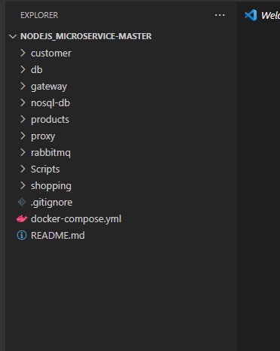

Figure 6.1.1: List of all the services in VSCode.

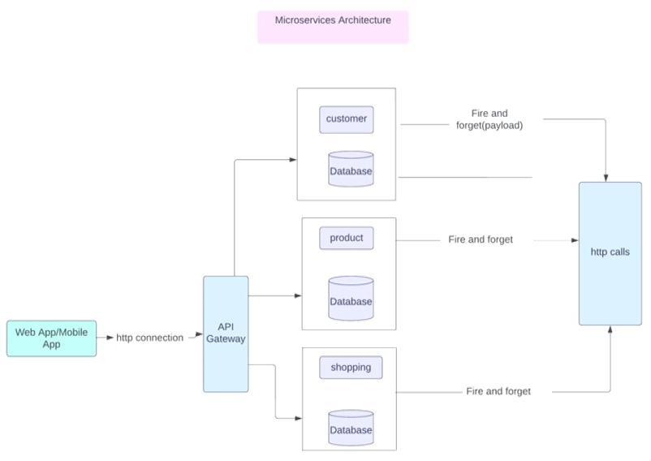

Figure 6.1.2: application architecture diagram.

## **Customer service**

This service has separate database in mongodb and depends on RabbitMQ and MongoDB to run successfully

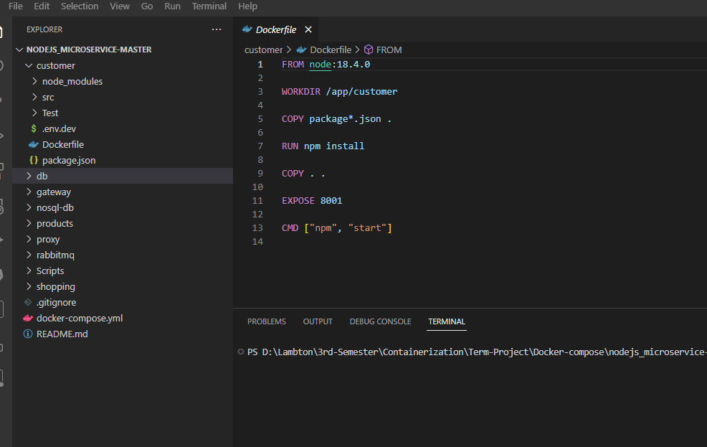

Figure 6.2.1: Dockerfile for the customer service, this service runs in port 8001.

## **Product service**

Similar to customer service product service also requires RabbitMQ and MongoDB.

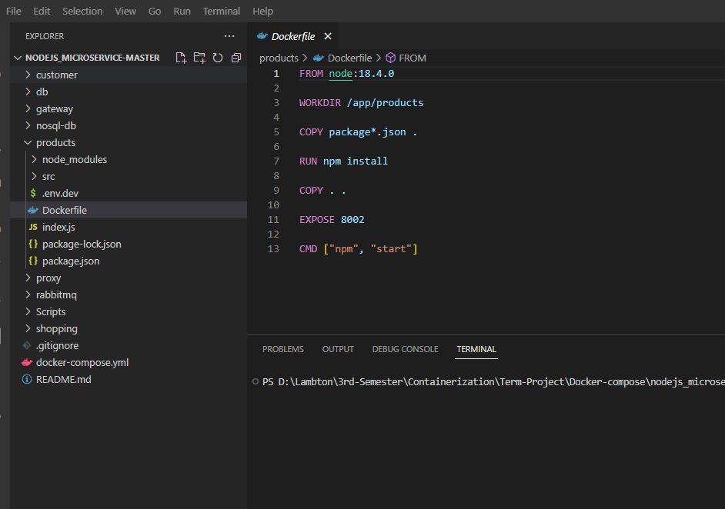

Figure 6.3.1: Dockerfile for the Product service, this service runs in port 8002.

## **Shopping service**

Similar to Product and Customer service shopping service requires RabbitMQ and MongoDB.

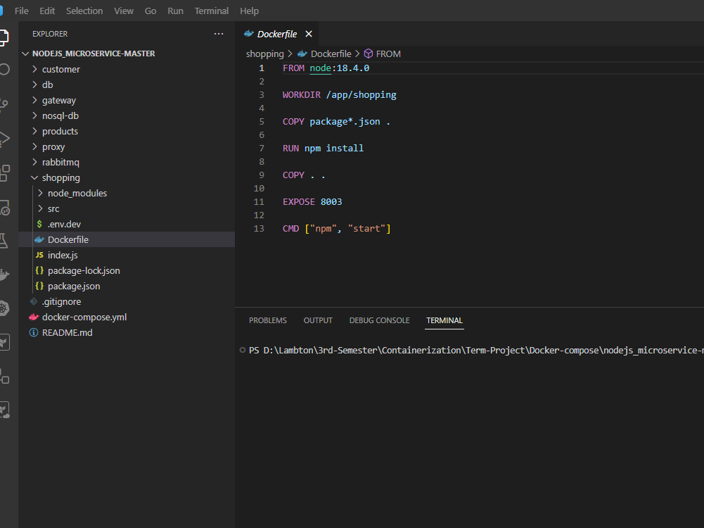

Figure 6.4.1: Dockerfile for the Shopping service, this service runs in port 8003.

## **Nginx Service**

Created the Nginx container which needs to modify the nginx.conf as request should be forwarded to each container and its respective port.

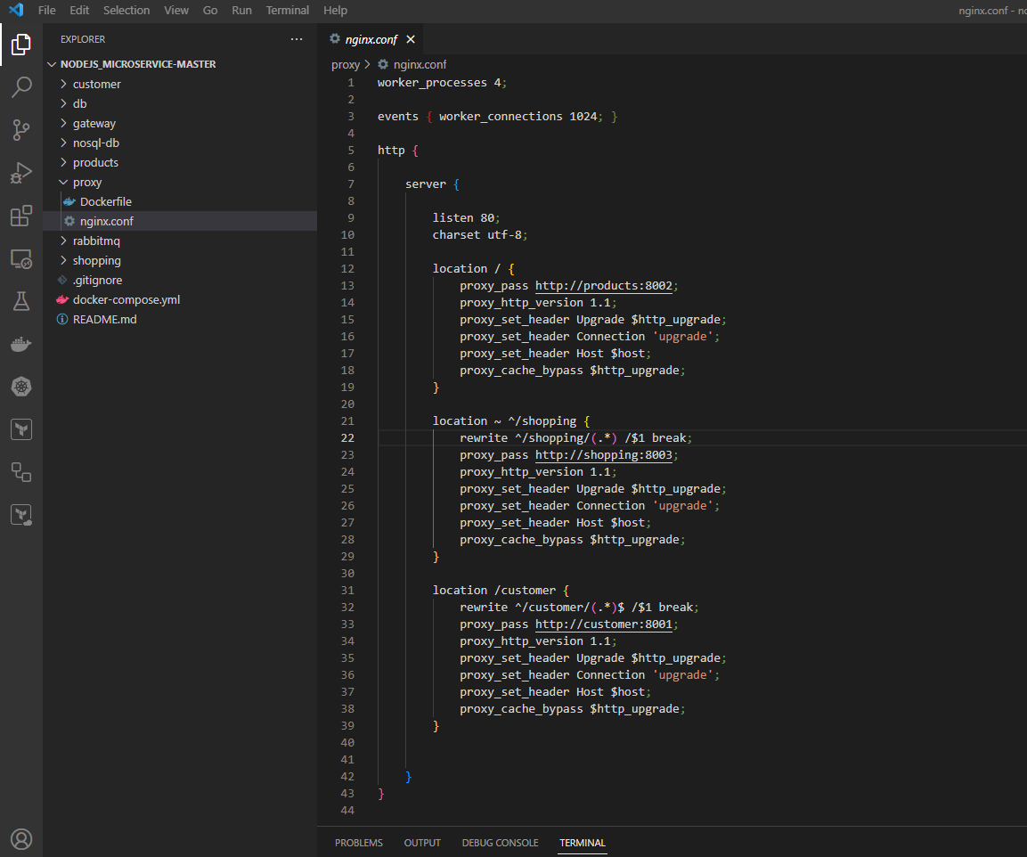

Figure 6.5.1: nginx.conf file which will be replaced inside the container.

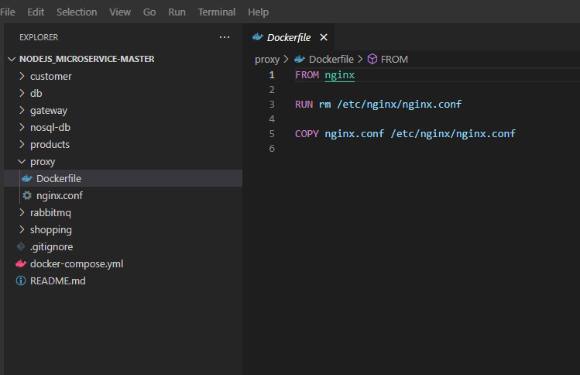

Figure 6.5.2: Created the Dockerfile to run the proxy.

## **Services**

Application requires 2 services RabbitMQ and NoSQL (MongoDB) which will be created inside the docker compose file

## **Docker Compose**

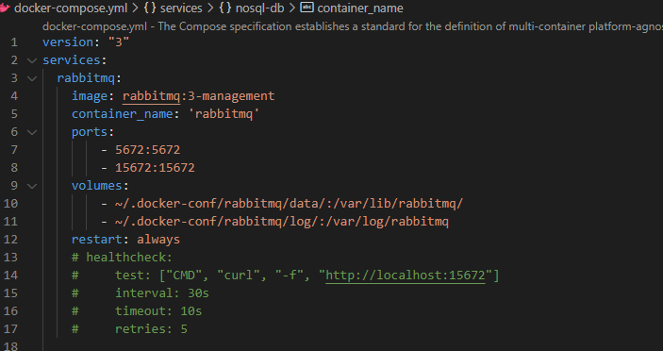

Figure 6.7.1: Docker compose file for running RabbitMQ

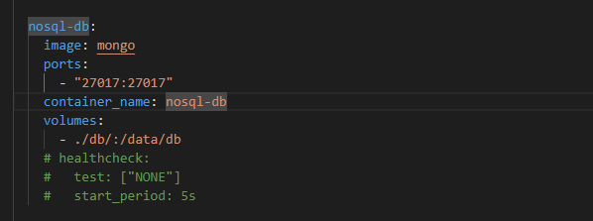

Figure 6.7.2: Docker compose file for running NoSQL (MongoDB)

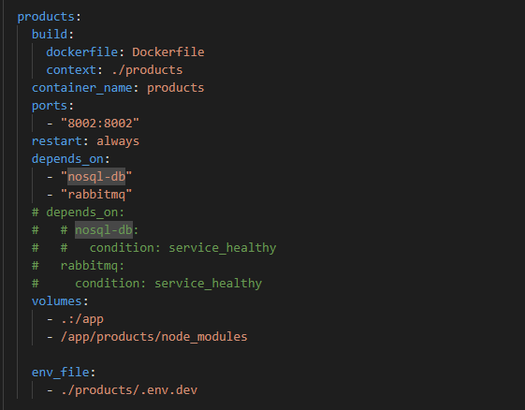

Figure 6.7.3: Customer service in docker compose file

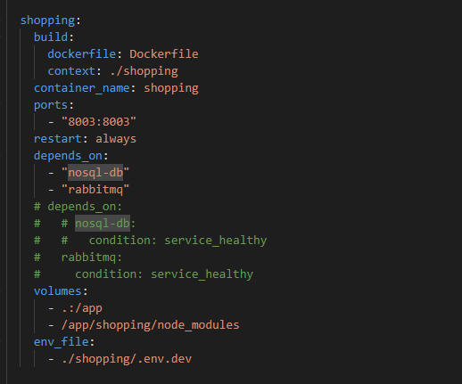

Figure 6.7.4: Docker Compose file for product service.

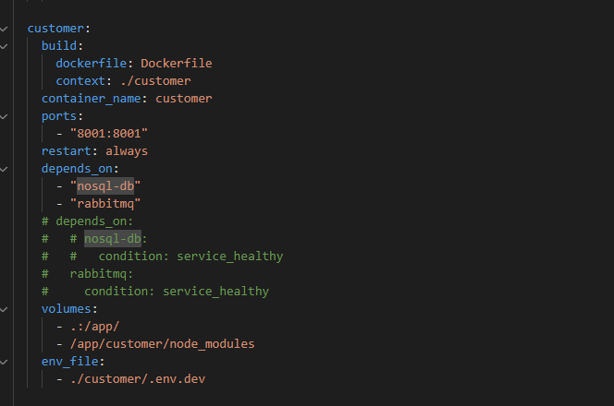

Figure 6.7.5: Docker compose file for customer service.

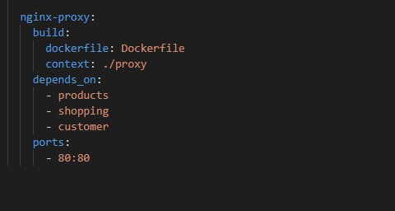

Figure 6.7.6: nginx proxy container in docker compose file.

## **Run the backend application using docker compose locally**

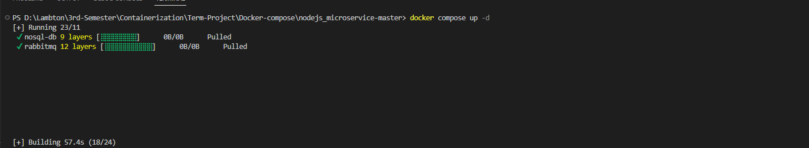

Figure 6.8.1: Run docker compose file which will pull the required image and running the application.



Figure 6.8.2: verifying all the containers are up and running.

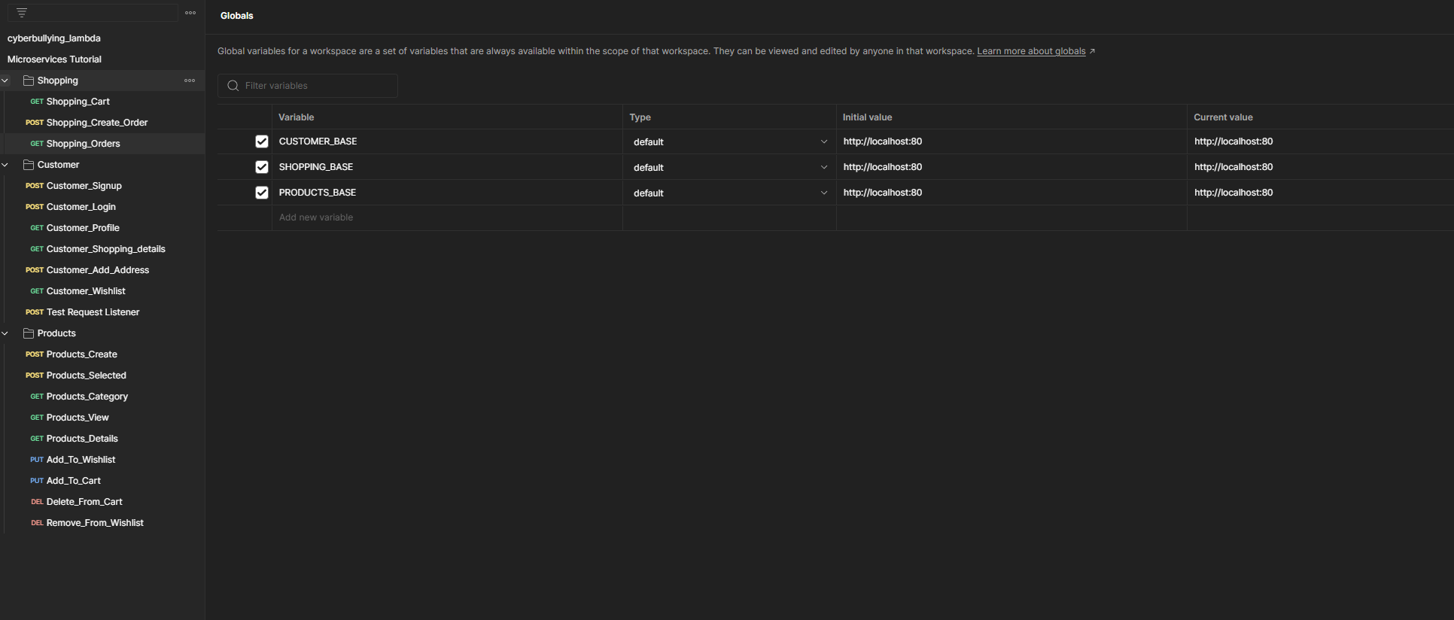

Figure 6.8.3: setup postman to run API calls to backend services.

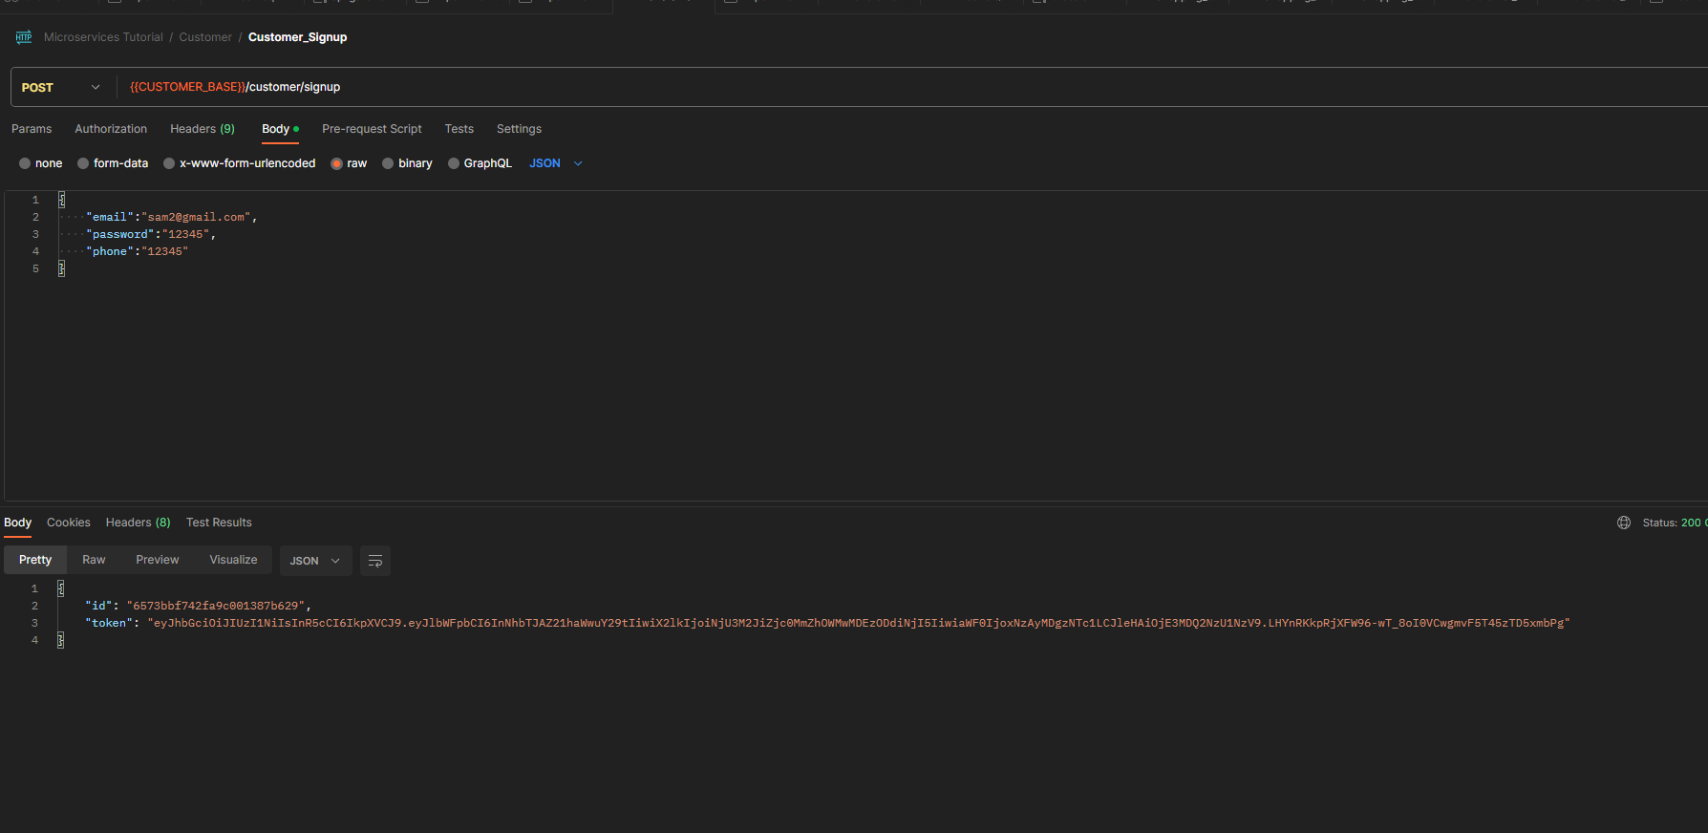

Figure 6.8.4: verifying customer backend service is working properly with an API call to the nginx proxy.

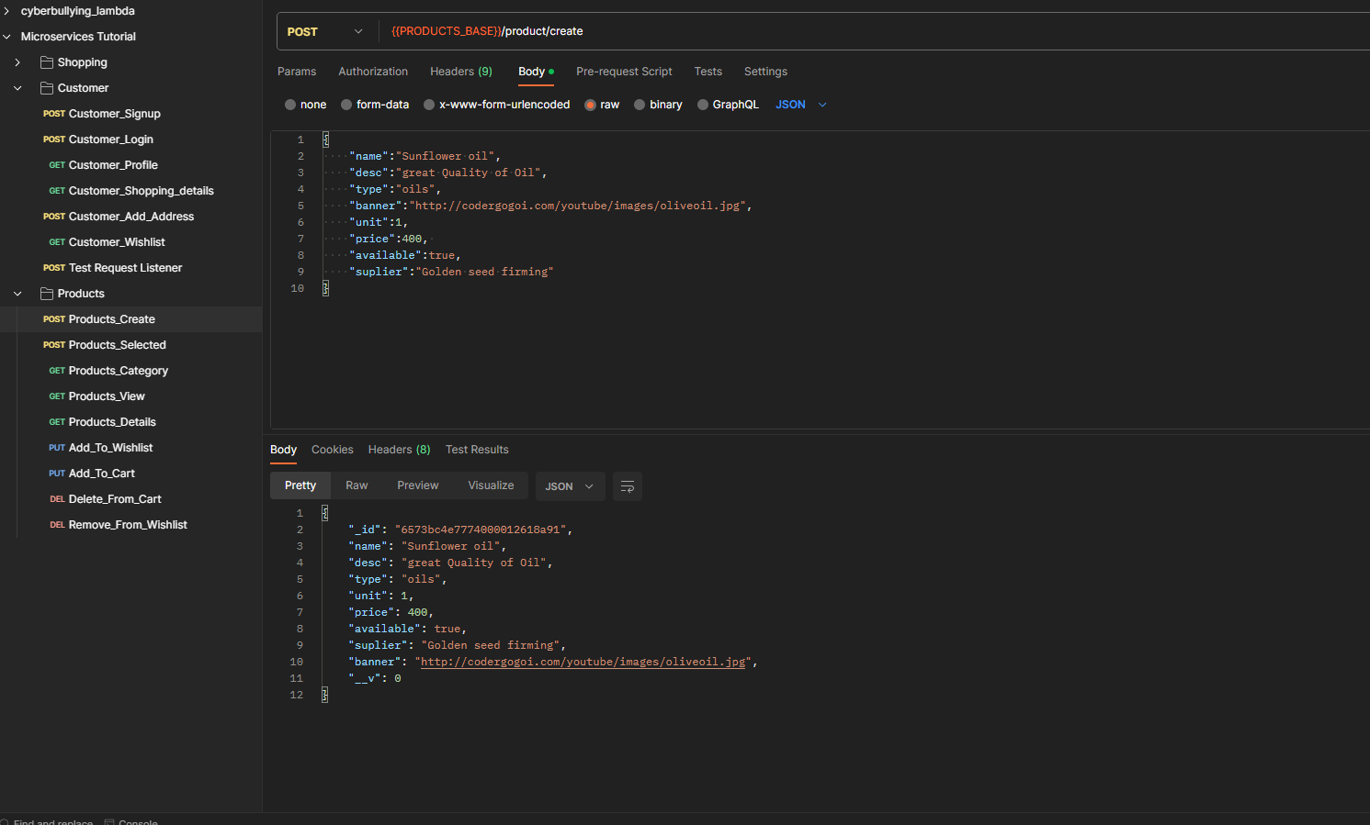

Figure 6.8.5: verifying product backend service is working properly with an API call to nginx proxy.

Ref github link: <https://github.com/pirabanjan/CBD-3324-Final>

# **Objective 7**

## **Application Kubernetes architecture**

This section focuses on implementing a container orchestration platform for the micro service application build in previous section.

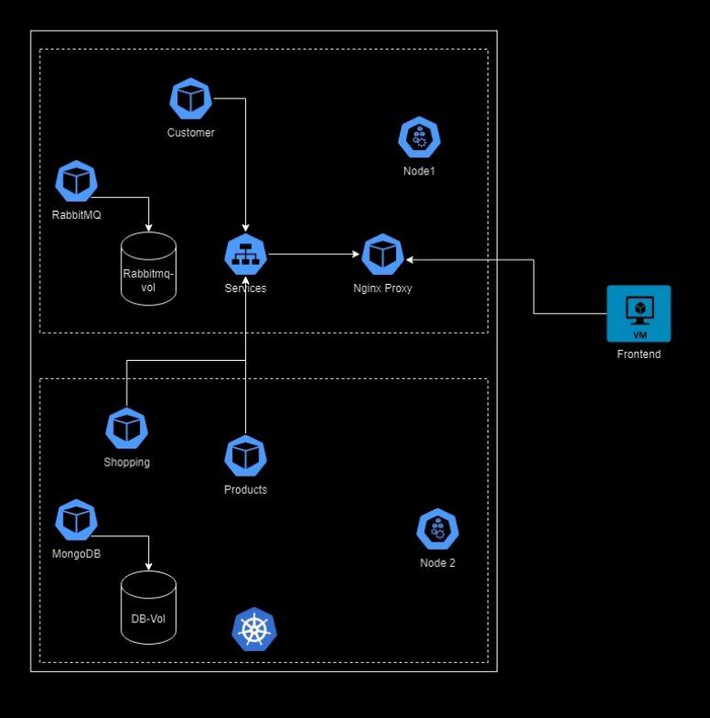

Figure 7.1.1: Kubernetes architecture diagram for the micro service application.

## **Customer K8s**

To create customer micro service in Kubernetes cluster we require to create deployment.yml, service.yml and to pass the variable we use configmap.yml

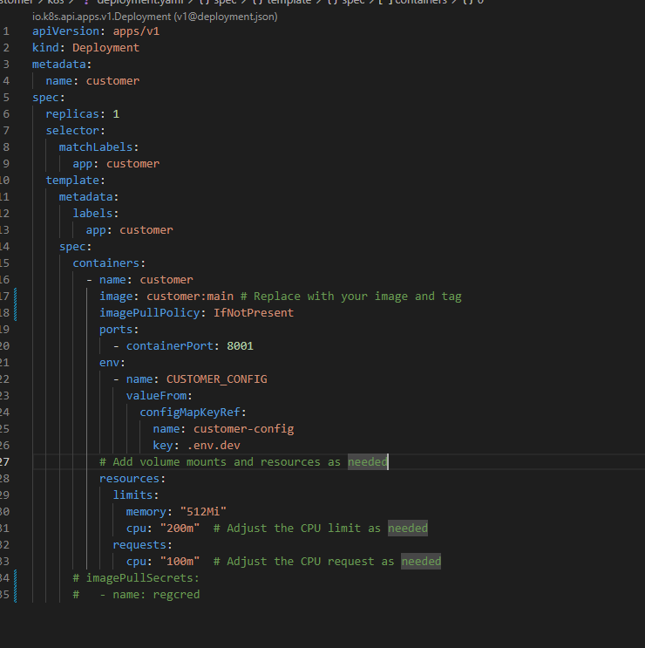

Figure 7.2.1: Deployment.yml file for the customer service.

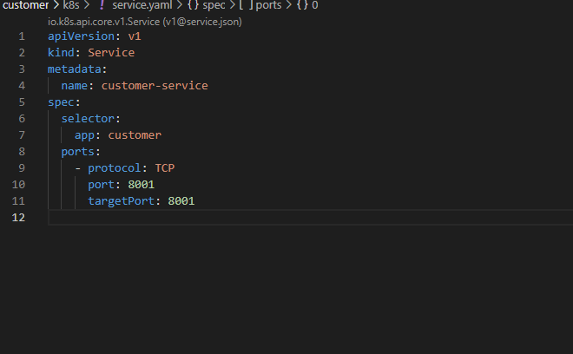

Figure 7.2.2: service.yml file of customer micro service.

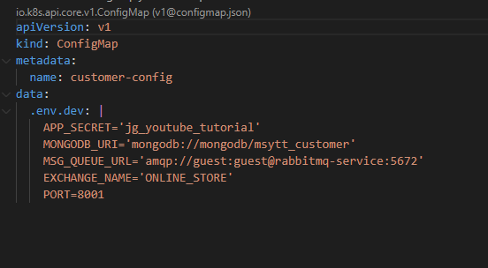

Figure 7.2.3: configmap.yml file to pass environment variables.

## **Product K8s**

Similar to the Customer service, Product service also requires 3 yaml file.

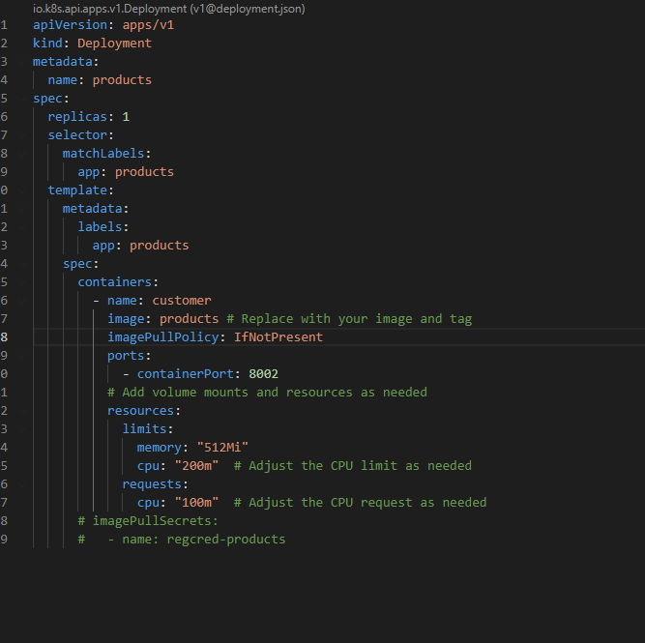

Figure 7.3.1: deployment.yaml file to deploy the product service to the k8s cluster.

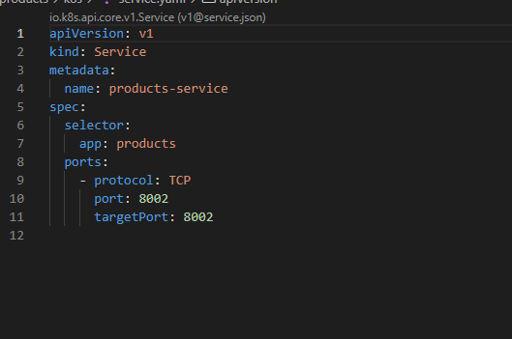

Figure 7.3.2: service.yaml file to deploy the service of product to the k8s cluster.

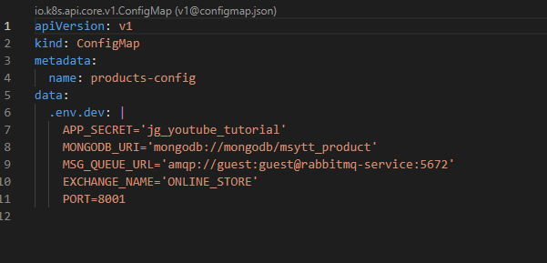

Figure 7.3.3: configmap.yaml file to deploy the product to the k8s cluster.

## **Shopping K8s**

Similar to product and customer service, its required to have deployment.configmap and service yaml files.

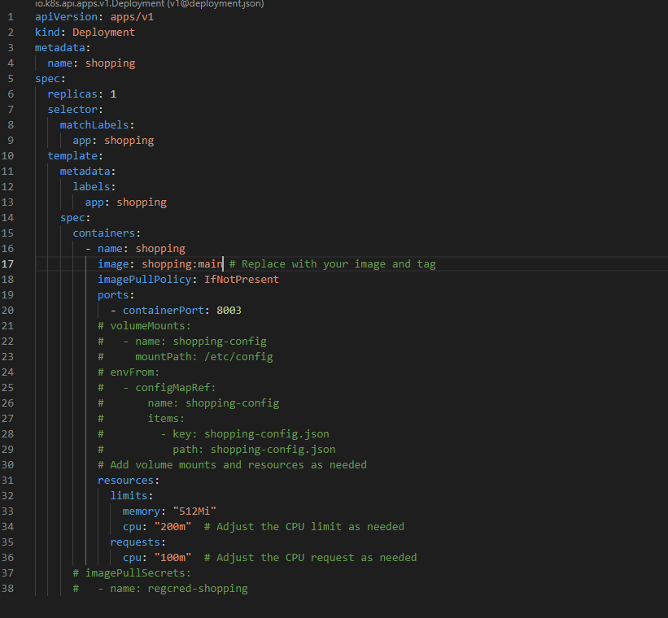

Figure 7.4.1: deployment.yaml file to deploy the micro service application into Kubernetes cluster

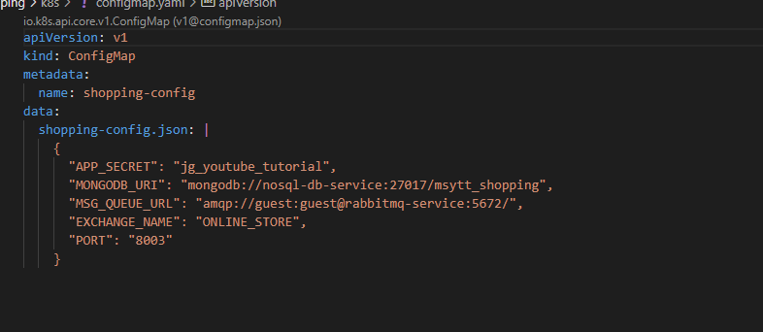

Figure 7.4.2: configmpa.yaml file to setup the environment variable for shopping micro service.

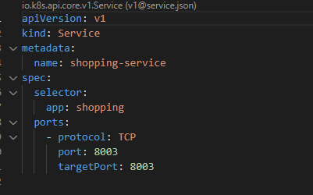

Figure 7.4.3: service.yaml file to run the shopping service application.

## **Database K8s**

To deploy the Database in Kubernetes cluster we require deployment.yaml file and service.yaml.

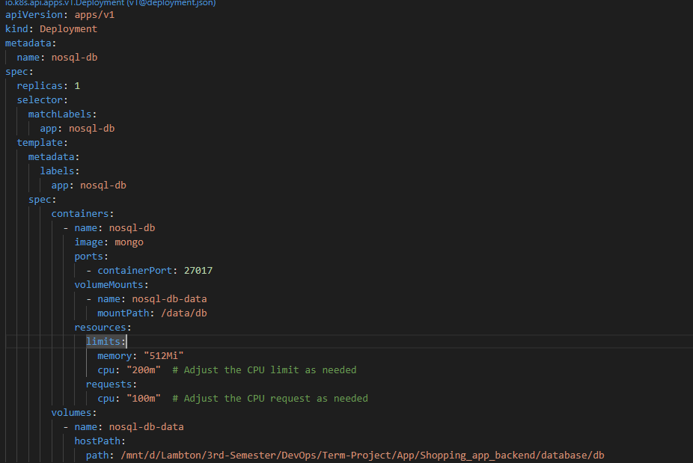

Figure 7.5.1: Deployment.yaml file to deploy the mongodb database and map the db file from local machine to the pod.

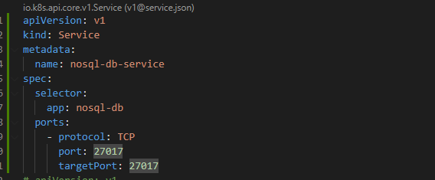

Figure: 7.5.2: Service.yaml file to run nosql-db service.

## **Nginx Proxy**

To deploy the proxy in the Kubernetes cluster run deployment.yaml file and service.yaml file.

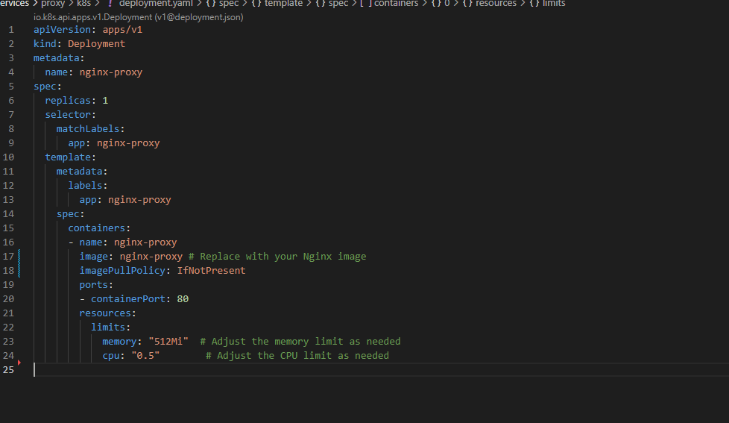

Figure 7.6.1: deployment.yaml file to deploy the nginx proxy into Kubernetes cluster.

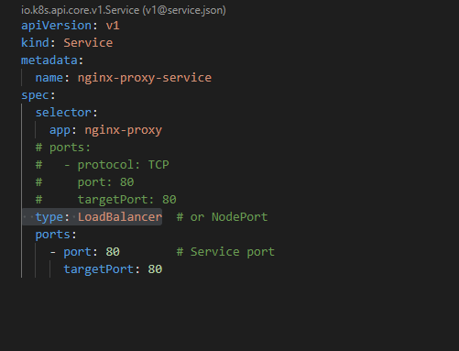

Figure 7.6.2: service.yaml file which opens the application in port 80 using loadbalancer type In Kubernetes cluster.

## **K8s RabbitMQ K8s**

To deploy the RabbitMQ into the cluster we required deployment.yaml file or service.yaml files

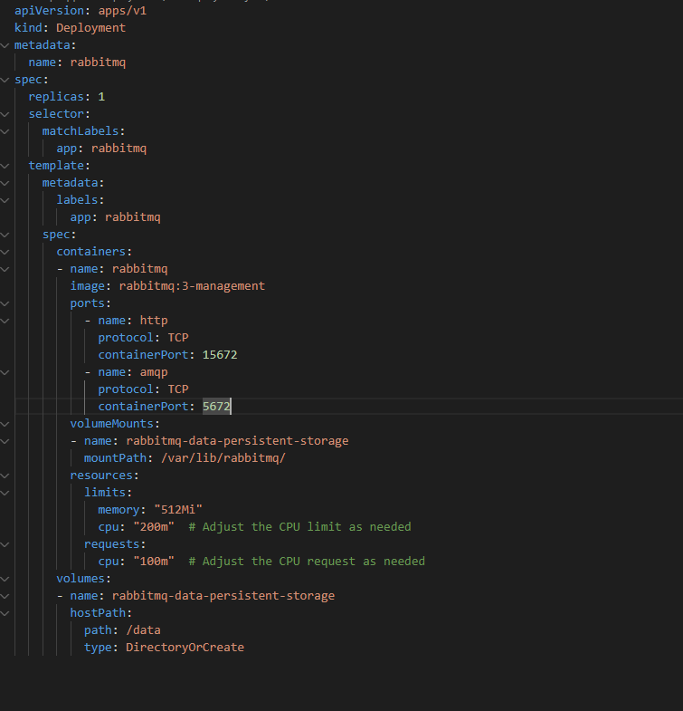

Figure 7.7.1: deployment.yaml file to deploy the RabbitMQ to the Kubernetes cluster.

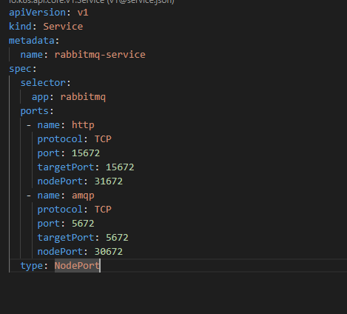

Figure 7.7.2: service.yaml file which expose port 5762 to the application and 15762 to for the management of RabbitMQ in the cluster.

## **Running the Kubernetes Cluster locally**



Figure 7.8.1: Kubernetes apply deployment and service file in RabbitMQ.



Figure 7.8.2: Kubernetes apply deployment and service file in MongoDB.

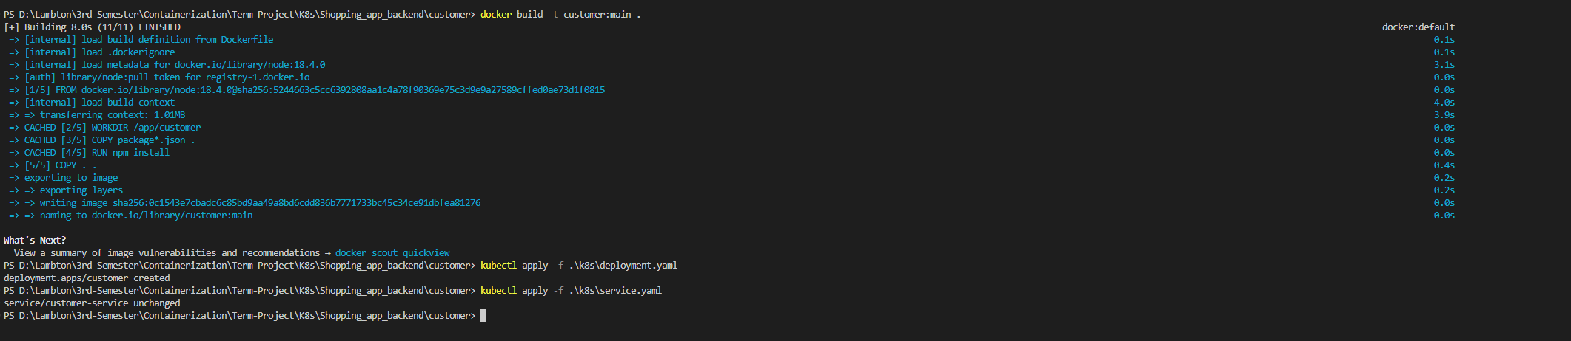

Figure 7.8.3: build and deploy the customer service in Kubernetes cluster.

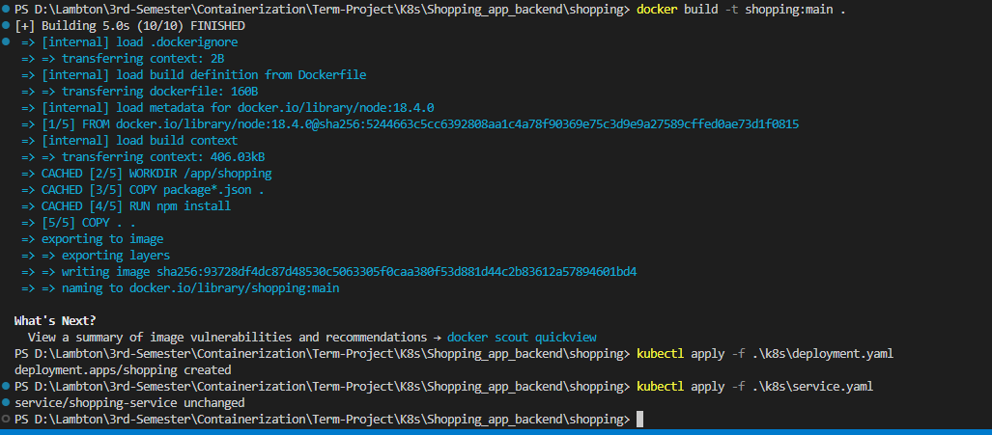

Figure 7.8.4: Build and deploy the shopping service in Kubernetes cluster.

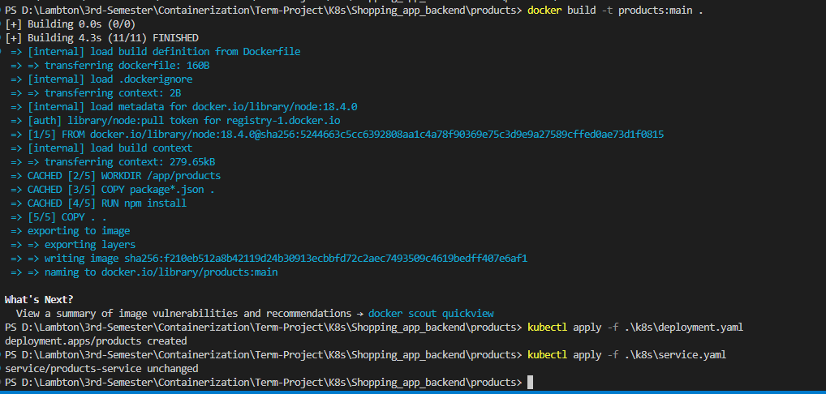

Figure 7.8.5: Build and deploy the product service in Kubernetes cluster

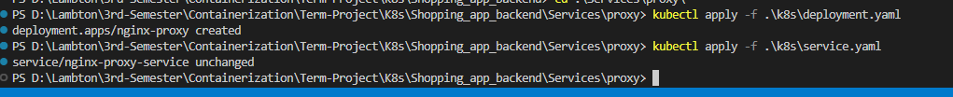

Figure 7.8.6: Running the Nginx service in Kubernetes cluster.

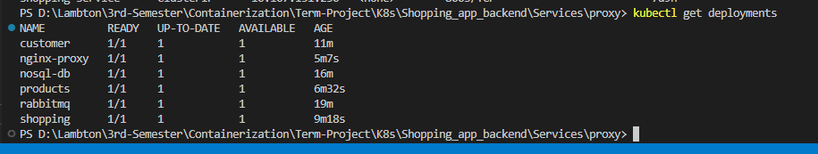

Figure 7.8.7: Verification of deployments in the cluster.

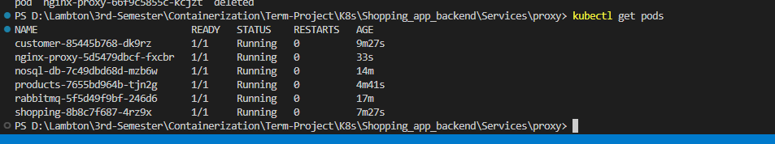

Figure 7.8.8: Verification all the pods are deployed in the cluster

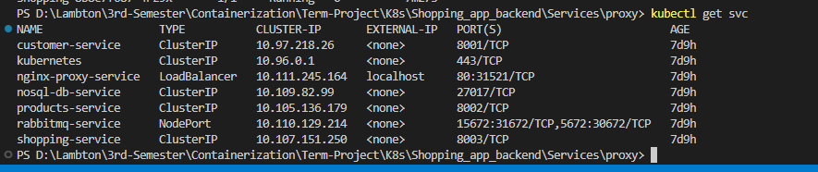

Figure 7.8.9: Verification of services running in the cluster.

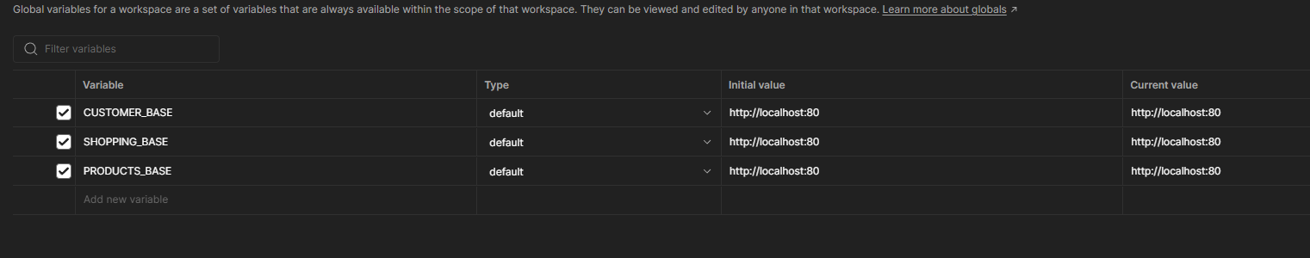

Figure 7.8.10: setting up the base URL in the Postman.

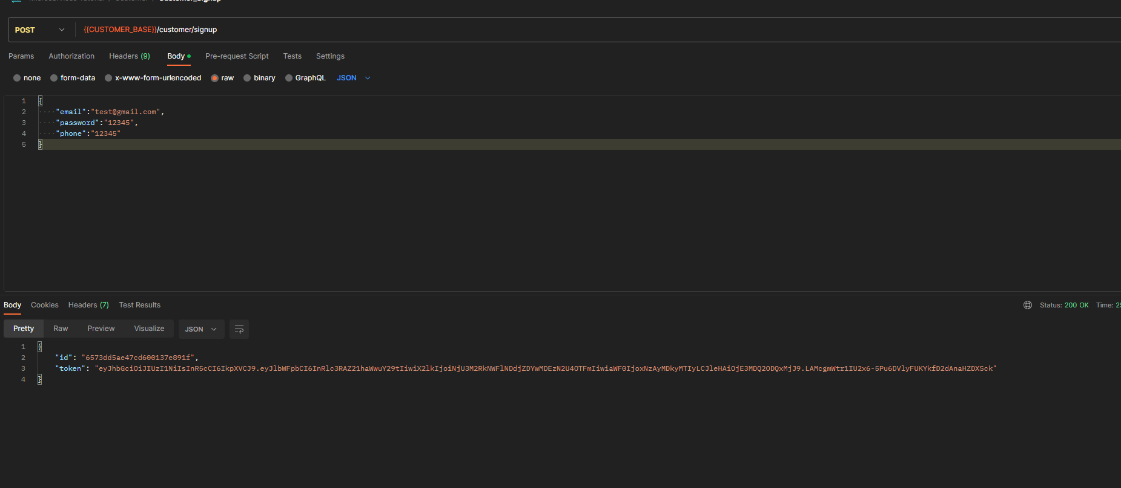Figure 7.8.11: verification customer service functions using API call.

Ref link for the K8s: <https://github.com/pirabanjan/CBD-3324-Final>

## **Running the Application Docker Swarm in EC2.**

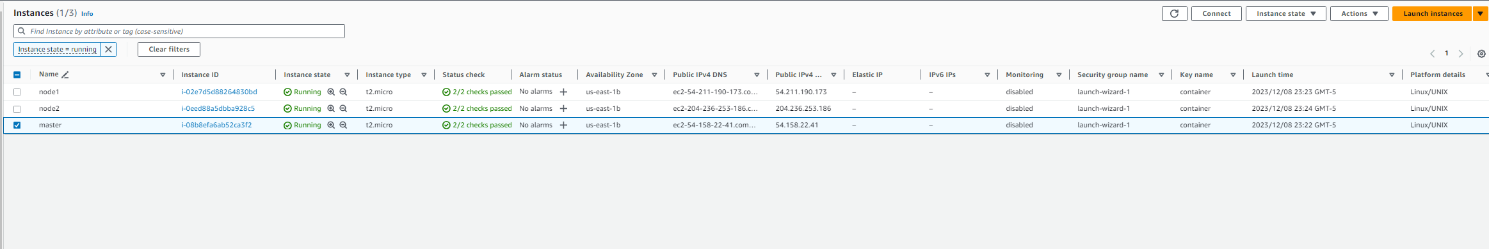

Figure 7.9.1: Created EC2 instance in AWS (master node and 2 worker nodes)

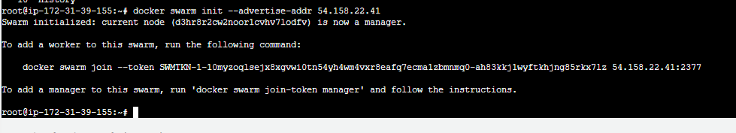

Figure 7.9.2: After installation of docker initiated docker swarm in master node.



Figure 7.9.3: After master node is initiated copied the token and added the worker node1 to the swarm using the token



Figure 7.9.4: After master node is initiated copied the token and added the worker node1 to the swarm using the token

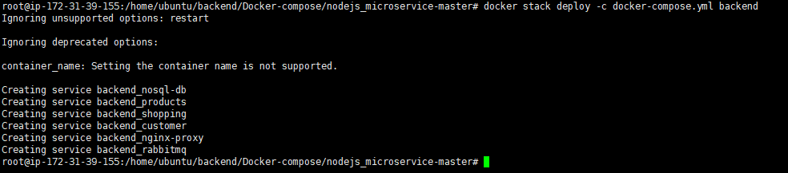

Figure 7.9.5: Created docker compose file and deployed the application using the stack

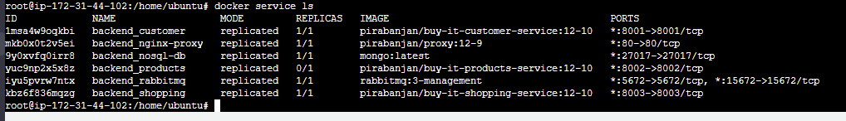

Figure 7.9.6: Verification of service running in docker swarm.

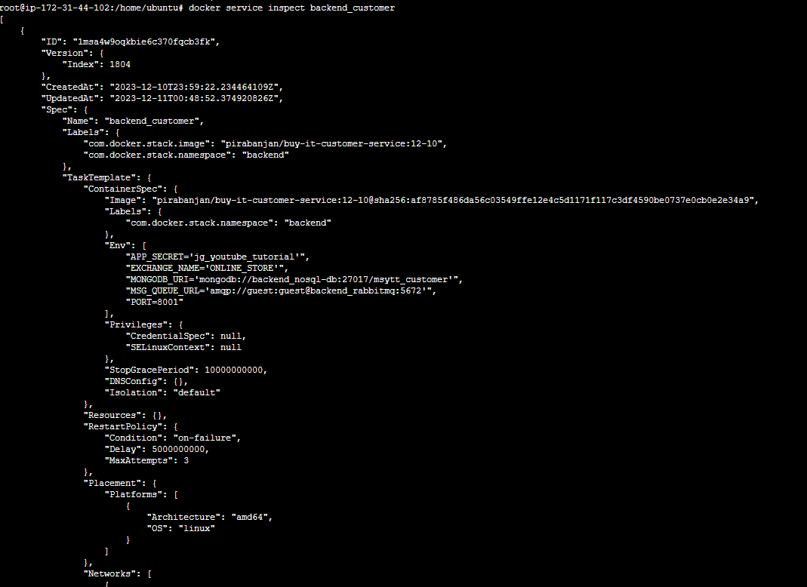

Figure 7.9.7: docker service inspect command to verify all the env values are pass correctly.



Figure 7.9.8: list the container associated with the customer service.

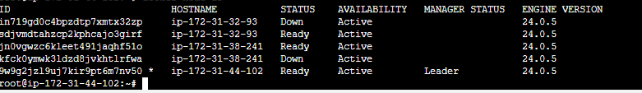

Figure 7.9.9: List all the nodes and check the status of the nodes from master.

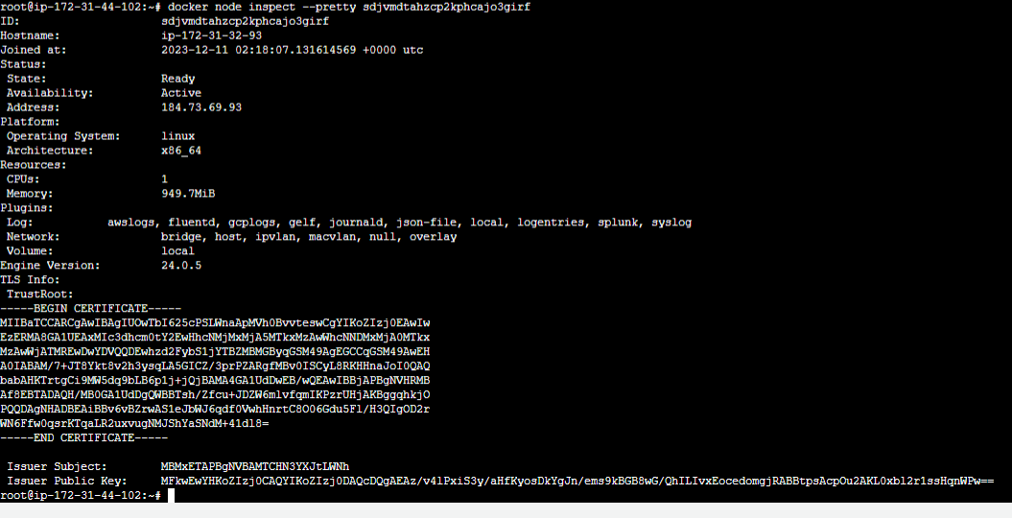

Figure 7.9.10: view resources usage on a specific node.

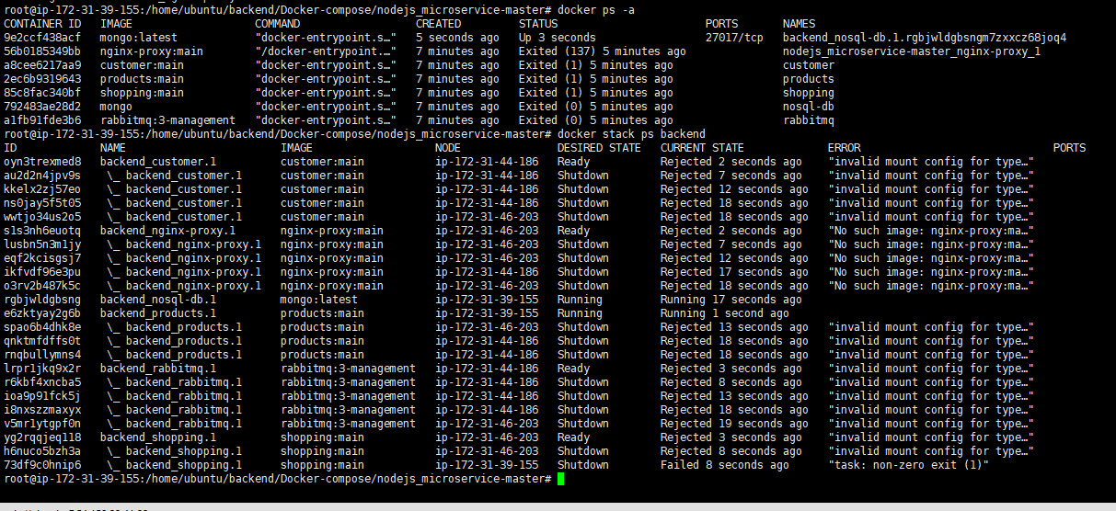

Figure 7.9.11: Verification of service running in docker swarm.

Ref link for the docker swarm: <https://github.com/pirabanjan/CBD-3324-Final>

# **References**

Ciena. (n.d.). What Is SDN? Retrieved from <https://www.ciena.com/insights/what-is/What-Is-SDN.html>

TechTarget. (n.d.). Software-defined applications and infrastructure explained. Retrieved from <https://www.techtarget.com/searchdatacenter/tip/Software-defined-applications-and-infrastructure-explained>

GeeksforGeeks. (n.d.). Virtualization in Cloud Computing - Types. Retrieved from <https://www.geeksforgeeks.org/virtualization-cloud-computing-types/>

Opensource.com. (n.d.). What is virtualization? Retrieved from <https://opensource.com/resources/virtualization>

Red Hat. (2023). What is a hypervisor? Red Hat. <https://www.redhat.com/en/topics/virtualization/what-is-a-hypervisor#:~:text=A%20hypervisor%20is%20software%20that,and%20management%20of%20those%20VMs>.

IBM. (2023). What is a hypervisor? IBM. <https://www.ibm.com/topics/hypervisors#:~:text=The%20hypervisor%2C%20also%20known%20as,power%2C%20memory%2C%20and%20storage>.

Amazon Web Services. (2023). What is a hypervisor? AWS. <https://aws.amazon.com/what-is/hypervisor/#:~:text=A%20hypervisor%20is%20a%20software,individual%20virtual%20machines%20as%20required>.

Red Hat. (n.d.). What Is Containerization? <https://www.redhat.com/en/topics/cloud-native-apps/what-is-containerization>

Docker. (n.d.). What is a Container? <https://www.docker.com/resources/what-container/>

Amazon Web Services. (n.d.). Containerization on AWS. <https://aws.amazon.com/what-is/containerization/>

IBM. (n.d.). Containerization: The Basics. <https://www.ibm.com/topics/containerization>

Trains. (n.d.). Containerization vs. Virtualization. <https://www.trianz.com/insights/containerization-vs-virtualization>

Liquid Web. (n.d.). Virtualization vs. Containerization. <https://www.liquidweb.com/kb/virtualization-vs-containerization/#:~:text=Virtualization%20relies%20on%20hypervisors%20and,agility%2C%20portability%2C%20and%20scalability>.

Ubuntu. (n.d.). Containerization vs. Virtualization. <https://ubuntu.com/blog/containerization-vs-virtualization>

Bael dung. (n.d.). Virtualization vs. Containerization. <https://www.baeldung.com/cs/virtualization-vs-containerization>

Burwood Group. (n.d.). Containerization vs. Virtualization. <https://www.burwood.com/blog-archive/containerization-vs-virtualization>

Tozzi, C. (2019). The Differences Between Linux and Windows Containers. <https://cloudnativenow.com/topics/cloudnativedevelopment/the-differences-between-linux-and-windows-containers/>

Neergaard, B., & Gregory, E. (2023). So, you want to run Windows containers. <https://www.mirantis.com/blog/so-you-want-to-run-windows-containers/>

David Swersky. (2018, October 11). An Insight into Docker and Its Resounding Popularity. [Website Name]. Retrieved from <https://raygun.com/blog/what-is-docker/>

(2023). Understanding Docker Architecture: A Comprehensive Overview. [Website Name]. Retrieved from <https://www.techtarget.com/searchitoperations/definition/Docker-Engine>

Praveen Dandu. (Year, Month Day). Understanding Docker Architecture: An In-depth Overview of Docker Components and Usage. [Website Name]. Retrieved from <https://praveendandu24.medium.com/understanding-docker-architecture-an-in-depth-overview-of-docker-components-and-usage-f1a26bd217f9>

Docker. (n.d.). docker version. Docker Documentation. [<https://docs.docker.com/engine/reference/commandline/version/>]

Digital Ocean. (Year, Month Day). The Docker Ecosystem: An Overview of Containerization. <https://www.digitalocean.com/community/tutorials/the-docker-ecosystem-an-overview-of-containerization>

[Author Last Name, First Initial]. (Year). [Title of the Book Chapter]. In [Book Title] (pp. [Page Range]). Packet Publishing. <https://subscription.packtpub.com/book/cloud-and-networking/9781838645700/1/ch01lvl1sec15/the-container-ecosystem>

Middleware. (Year, Month Day). Understanding the Docker Ecosystem. <https://middleware.io/blog/understanding-the-docker-ecosystem/>

Aqua. (n.d.). Container DevOps. Retrieved from <https://www.aquasec.com/cloud-native-academy/docker-container/container-devops/#:~:text=What%20Does%20Containerization%20Mean%20for,%2Dpremises%20or%20cloud%2Dbased>.

Microsoft. (n.d.). Containerized Docker Application Lifecycle with Microsoft Platform and Tools. Retrieved from <https://learn.microsoft.com/en-us/dotnet/architecture/containerized-lifecycle/docker-application-lifecycle/containers-foundation-for-devops-collaboration>

Xenon Stack. (n.d.). Containers in DevOps. Retrieved from <https://www.xenonstack.com/insights/containers-in-devops/>

"What’s The Difference Between Containers and Microservices?" Nordic APIs. <https://nordicapis.com/whats-the-difference-between-containers-and-microservices/>

"Containers vs. Microservices: Which is the Best Approach?" BMC Blogs. <https://www.bmc.com/blogs/containers-vs-microservices/>

"Container and Microservices with Ingress Gateway." Avi Networks. <https://avinetworks.com/what-are-microservices-and-containers/>